EAS 345 HYDROLOGY Lab #1 Name_________________________________________

Last First

**WATERSHEDS AND DISCHARGE**

**On All Math Problems, show work**

**Introduction**

One of the main jobs of hydrologists is to determine the water budget of a region. This is done by first determining the **watershed,** **basin, or catchment area** of each river. Most basins resemble a tree with many branches. All trees or basins can be separated from each other by drawing a line that outlines their area, never crossing a stream. The boundaries of the basins are lines called **divides**, which represent the ridges or high points. Divides can be pinpointed with contour maps. (Note: Sometimes the watershed boundary does not coincide with the divide. A possible mismatch occurs when an impermeable rock layer tilted in the opposite direction from the surface topography diverts water underground from higher to lower ground. This seldom caused a major change in a watershed’s outline.)

Once the basin has been outlined, the rate at which water is available is proportional to its area, ***A*** and the average rainfall rate, ***R***. The volume flow rate or **discharge**, *q* (m3 s-1) of water at any point in the river is given by the

**Discharge Equation**,



*E* is the fraction of water that reaches the stream. (Much is lost to evaporation.)

Determining the area average rainfall is not easy since data comes from widely and irregularly spaced stations. Average rainfall over a basin can be determined using contour analysis (see Lab 2).

# Measuring Stream Flow

The current velocity of a stream is measured by a current meter, which may be a propeller that drives a generator. A bridge is constructed over the stream and the meter is lowered into the stream. Total stream discharge is measured by dividing the stream into segments, measuring the current speed from top to bottom of the stream in each segment, taking the average velocity and then multiplying by the width, y times the depth, z of each segment. The discharge of that segment is then given by,



1

Usually, the relation between the maximum current speed (which occurs just below the water surface) and the average current speed integrated over depth is,

*v*avg ≈ 0.8*v*max

**Exercises**

**1. On the map of the Walnut Creek and Elk Creek watershed:**

a. Outline the drainage area above the Gaging station on Walnut Creek and above the Box Canyon Dam site.

b. Use the red grid to estimate each of the areas.

c. If the area above the Gaging station is 150 square miles, then using proportions, the area above the Box Canyon Dam should be,

ABox = _____________ mi2

If the discharge at the Gaging station is 25 m3 s-1 calculate expected *q* at the Box Canyon Dam site.

q(Box Canyon Dam Site) = ________ m3 s-1.

2. On the map of South America

a. Outline the watershed for the Amazon River.

b. Estimate its area using the grid (Each square = 5º latitude = 556 km). Thus the area of

each square = ________ km2 and the area of the Amazon Basin is roughly AAmazon = __________km2

c. Estimate Rainfall in m/yr for each square in the Amazon Basin on the rainfall contour map of South America. Take the average of all squares in the basin and then divide by the number of seconds in a year to find the average R. Then, calculate potential discharge, *q*pot of the Amazon River assuming E = 1.

*R* = _______ m s-1

*q*pot = ______m3 s-1

d Given that the actual average discharge of the Amazon is *q*Amazon = 175,000 m3 s-1, use the Discharge Equation to calculate the efficiency, *E* of the Amazon basin,

*E* = ___________

The remaining fraction is lost to evaporation.

3. Draw heavy lines to mark the **divides** between watersheds from streams on the contour map of A: Dolomite Creek (see **dolomite_creek.ppt**), B: Dixs Grant, New Hampshire.

4. A river basin with area, *A* = 15,000 km2 receives 1 cm of precipitation in 24 hours. If 35% of the rain runs into the river, calculate the discharge,

*q* = __________ m3 s-1

5. The average speed of the current is 1.5 ms-1 in a river 2 m deep and 275 m wide. Calculate the discharge of the river.

*q* = __________ m3 s-1

6. Find the average current velocity, cross section area (depth x width) and wetted perimeter, Pwet (length of the river bed that is under water) in each segment and total discharge for the stream given in the table below. Enter into EXCEL or MATLAB the data sheet. Using the EXCEL spreadsheet create a chart that shows the river cross section. The hydraulic radius, R is the total cross section area divided by the wetted perimeter

|  |  |  |  |  |  |  |
| --- | --- | --- | --- | --- | --- | --- |
| X | Z | vmax | vavg | q | Axs | Pwet |
| 0 | 0 |  | X | X | X | X |
| 5 |  | 0.75 |  |  |  |  |
| 10 | 1.5 |  | X | X | X | X |
| 15 |  | 1.33 |  |  |  |  |
| 20 | 2.7 |  | X | X | X | X |
| 25 |  | 1.96 |  |  |  |  |
| 30 | 3.6 |  | X | X | X | X |
| 35 |  | 2.33 |  |  |  |  |
| 40 | 4.4 |  | X | X | X | X |
| 45 |  | 2.21 |  |  |  |  |
| 50 | 2.9 |  | X | X | X | X |
| 55 |  | 1.57 |  |  |  |  |
| 60 | 0 |  | X | X | X | X |
|  |  |  | Total = |  |  |  |

qtot = ________ Pwet = ________ A = _________ R = _______

7. Rivers of water vapor flow through the invisible atmosphere. On a day of strong south winds in the late spring or summer, air flows northward across Texas and Louisiana at an average speed of *v* = 10 m s-1 over a depth, *z* = 1500 m and a width, *y* = 1200 km. If every cubic meter of air contains 10 g of vapor, and all the vapor condenses and returns down the Mississippi River, calculate the volume of condensed water in each cubic meter of air and then, the potential discharge of the Mississippi. The actual discharge will be much smaller because this vapor flux does not occur at this rate all year and also because winds carry much vapor out of the region on its northern and eastern borders.

*V*cond = _______ m3

*q*pot = __________ m3 s-1

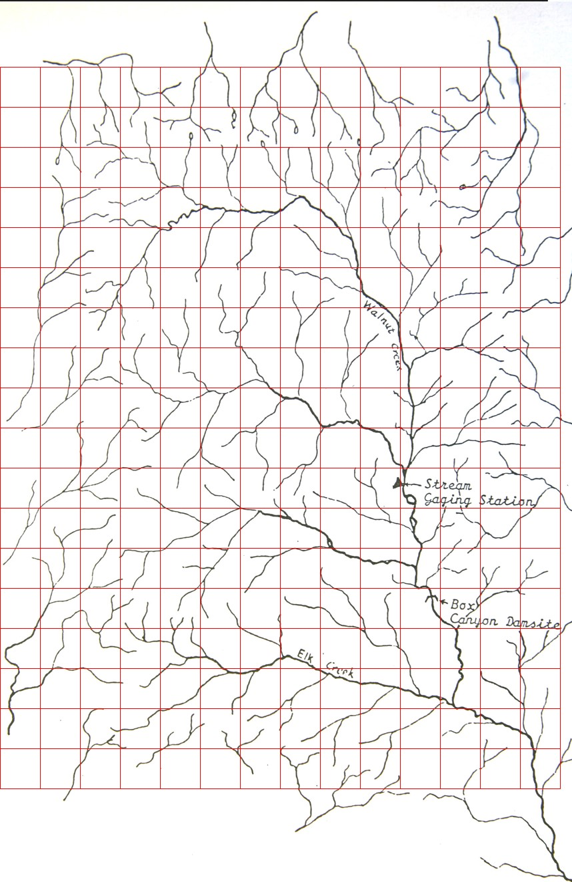

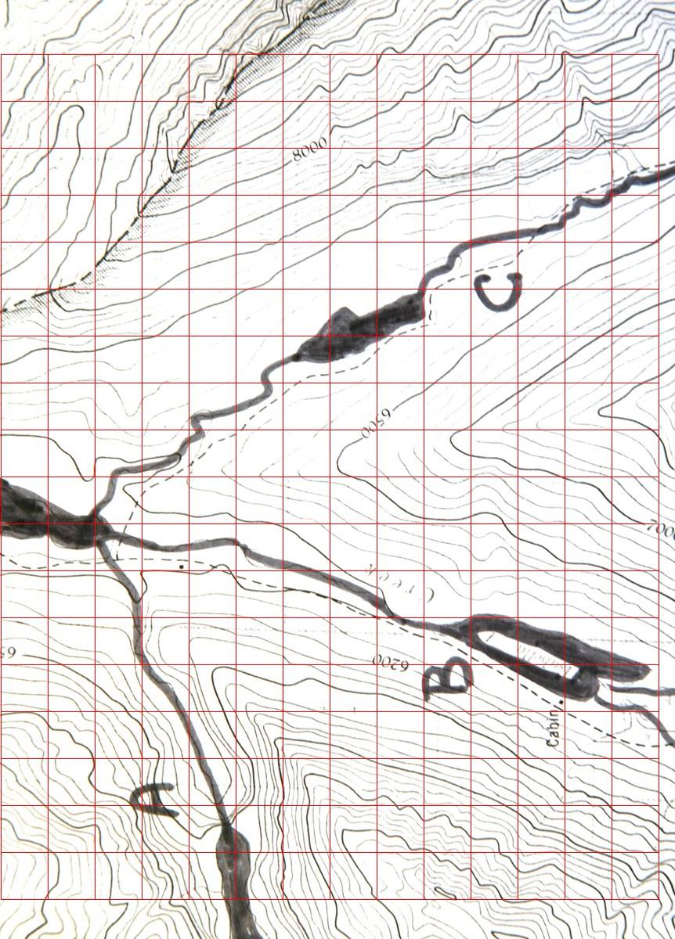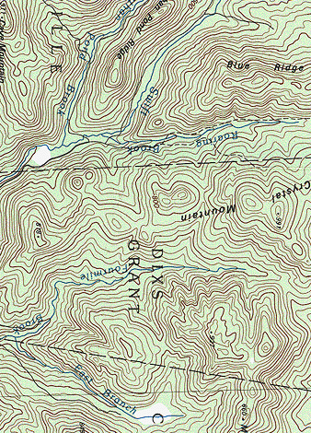

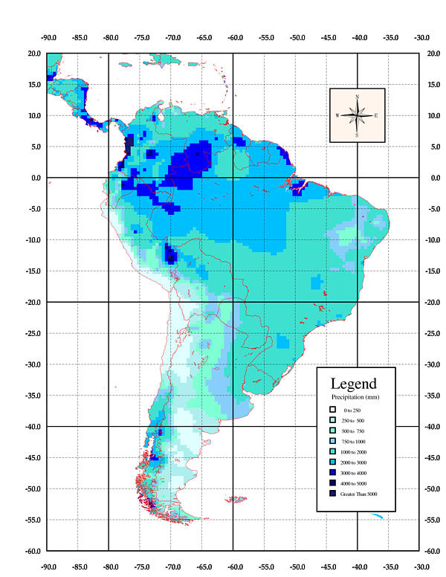

<http://www.r-hydronet.sr.unh.edu/english/>

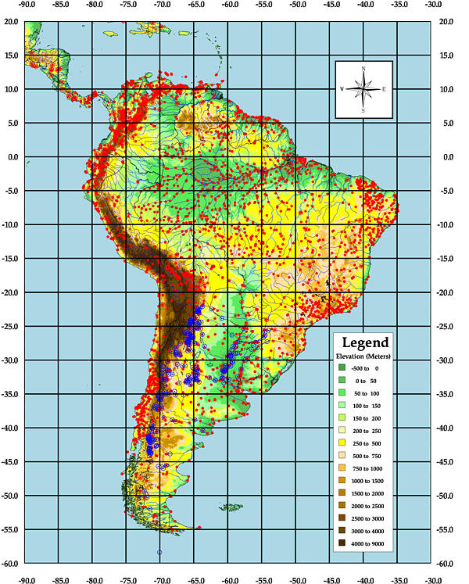

EAS 345 HYDROLOGY Lab #2 Name____________________________________________

Last First

**PRECIPITATION, CONTOURS, AND RIVER DISCHARGE**

**On All Math Problems, show work**

**Introduction**

The purpose of this lab is to investigate some of the basic relationships between rainfall and runoff or discharge. To evaluate discharge using the equation of discharge, *q = ERA*, it is necessary to determine the area of the catchment basin and the area-averaged rainfall rate. In Lab 1 you learned how to outline the catchment basin. Now we must learn to estimate area-averaged rainfall. The best way to do this with data from irregularly spaced rain gages or radar is to perform a contour analysis. In this lab we

1. Use contour lines created by others to calculate average rainfall
2. Construct our own contour analysis

A number of factors affect the runoff efficiency, E in the equation of discharge. They include:

1. Evaporation
2. Storage in groundwater
3. Time lag in reaching the river
4. Storage as snow or loss of storage due to melting

In the last part of the lab the impact of these and other factors is evaluated by comparing average monthly runoff of several major rivers to the monthly rainfall.

**Problems**

1. A tropical depression in the Southeastern Gulf of Mexico produced heavy rains over southwest Florida in late June, 1992. Four day amounts of 20 to 35 cm were common with the greatest totals up to 58 cm. The heaviest rains fell on Manatee and Sarasota counties where rivers and small streams flooded homes and roads. Two deaths resulted from the flooding.

Calculate the average rainfall and total volume of water and mean discharge, q, in two river basins, the Myakka River and the Peace River using the rainfall contours on the accompanying map and Myakka.ppt.

Procedure

a. Outline the basin of each of the rivers in a distinct color.

b. Use the grid to estimate the area of each basin in m2. The method is simply to count boxes and multiply by the area of each box (20 km) using the map scale.

Box Length = _____________ m Box Area = _______________ m2

Basin Area: Myakka River_________________m2 . Peace River__________________m2

c. Use the grid to estimate the average rainfall for each basin. The method is to estimate the rainfall at the center of each grid box and then average. Convert rainfall to meters.

Rain Depth: Myakka River_________________m Peace River__________________m

d. Calculate the total volume of water assuming a four day period that must flow through the mouth of each river during the time period assuming all rain reaches the rivers. Then calculate the discharge, q in m3 s-1.

Total Volume: Myakka River_________________m3 Peace River__________________m3

qMyakka_________________m3 s-1 qPeace________________m3 s-1

2. To show the value of contouring, A: Calculate the station average rainfall based on the grid below. B: Contour the rainfall using an interval of 5. C: In each box enter values of rainfall you expect in each box based on your contour analysis. D: Calculate the area average rainfall using the values in every box

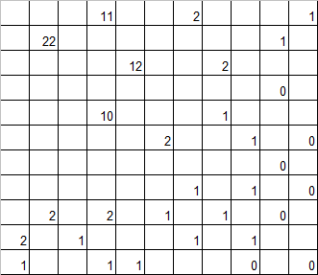

A: Station Average = ________________ D: Area Average = ___________________

3. Contour the values in the grid on page 4 using a contour interval = 20.

4. Rainfalls and discharges for 4 river basins (Niger, Tiber, Delaware, Yenesei) are included on the last page of this lab.

1. Use EXCEL or MATLAB to graph the monthly average rainfall and average discharge for each river.
2. For the Niger and Delaware Rivers, find the lag in months at which the maximum correlation between runoff, q and rainfall, R occurs and the correlation coefficient. Give the reason the maximum correlation is larger for the Niger than for the Delaware River.

Reason = ______________________________________________________________________________

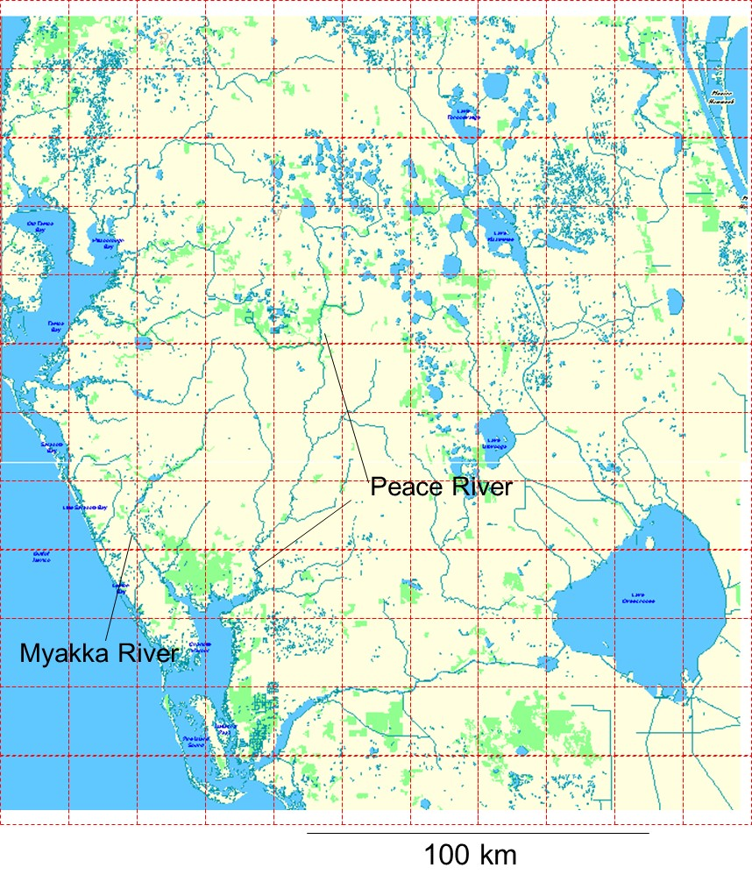

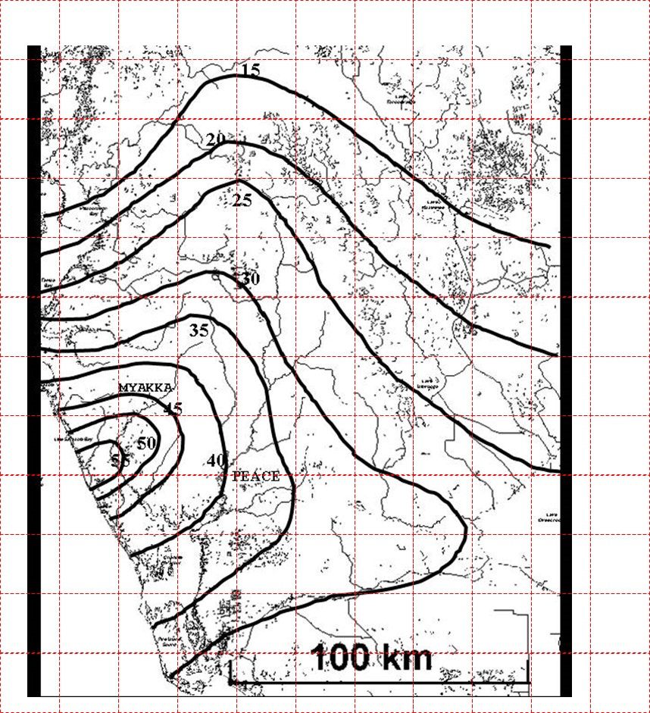

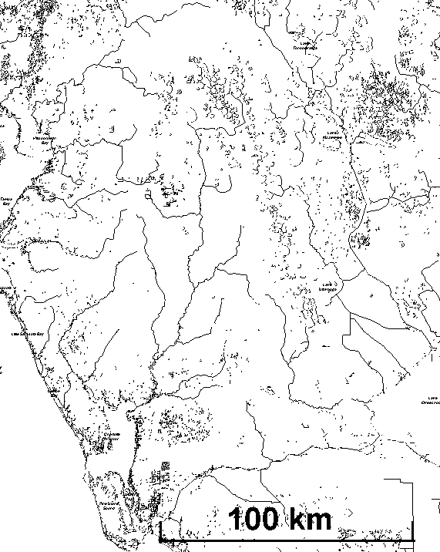

## MYAKKA

**PEACE**

**15**

**25**

**20**

**35**

**45**

**55**

**30**

**40**

**50**



# Rainfall and Discharge for Several Rivers Around the World

|  |  |  |  |  |  |  |  |  |  |  |  |
| --- | --- | --- | --- | --- | --- | --- | --- | --- | --- | --- | --- |
|  | Niger |  |  |  | Tibr |  | Del |  | Yenes |  |  |
|  | R | q | q | q | R | q | R |  |  |  |  |
| Mnth | Kays | Koul | Mpti | Dir | Rom | Rom | Trnt | Trnt | Irkutsk | Igarka |  |
| Jan | 0.1 | 403 | 992 | 2030 | 2.7 | 301 | 2.6 | 351 | 0.4 | 4840 |  |
| Feb | 0 | 196 | 400 | 1550 | 2.3 | 343 | 2.2 | 353 | 0.3 | 4510 |  |
| Mar | 0 | 101 | 185 | 967 | 1.5 | 325 | 2.9 | 611 | 0.3 | 4190 |  |
| Apr | 0 | 67 | 130 | 434 | 1.7 | 272 | 3 | 653 | 0.2 | 3980 |  |
| May | 1 | 98 | 82 | 141 | 2 | 242 | 3.7 | 387 | 1.5 | 30200 |  |
| Jun | 3.8 | 359 | 194 | 82 | 1 | 168 | 3.6 | 235 | 2.2 | 76000 |  |
| July | 6.3 | 1250 | 708 | 259 | 0.6 | 137 | 3.6 | 197 | 3.5 | 27900 |  |
| Aug | 9.5 | 3230 | 1760 | 841 | 0.9 | 123 | 3.2 | 170 | 3.1 | 18900 |  |
| Sep | 7.4 | 5380 | 2580 | 1490 | 2.7 | 134 | 2.6 | 157 | 1.7 | 17900 |  |
| Oct | 1.7 | 4680 | 2840 | 1890 | 3.7 | 177 | 3.1 | 179 | 0.7 | 14700 |  |
| Nov | 0 | 2130 | 2690 | 2150 | 3.8 | 264 | 2.7 | 292 | 0.7 | 6120 |  |
| Dec | 0 | 880 | 2000 | 2300 | 2.8 | 234 | 2.6 | 334 | 0.6 | 4880 |  |
| Jan | 0.1 | 403 | 992 | 2030 | 2.7 | 301 | 2.6 | 351 | 0.4 | 4840 |  |
| Feb | 0 | 196 | 400 | 1550 | 2.3 | 343 | 2.2 | 353 | 0.3 | 4510 |  |
| Mar | 0 | 101 | 185 | 967 | 1.5 | 325 | 2.9 | 611 | 0.3 | 4190 |  |
| Apr | 0 | 67 | 130 | 434 | 1.7 | 272 | 3 | 653 | 0.2 | 3980 |  |
| May | 1 | 98 | 82 | 141 | 2 | 242 | 3.7 | 387 | 1.5 | 30200 |  |
| Jun | 3.8 | 359 | 194 | 82 | 1 | 168 | 3.6 | 235 | 2.2 | 76000 |  |
| July | 6.3 | 1250 | 708 | 259 | 0.6 | 137 | 3.6 | 197 | 3.5 | 27900 |  |
| Aug | 9.5 | 3230 | 1760 | 841 | 0.9 | 123 | 3.2 | 170 | 3.1 | 18900 |  |
| Sep | 7.4 | 5380 | 2580 | 1490 | 2.7 | 134 | 2.6 | 157 | 1.7 | 17900 |  |
| Oct | 1.7 | 4680 | 2840 | 1890 | 3.7 | 177 | 3.1 | 179 | 0.7 | 14700 |  |
| Nov | 0 | 2130 | 2690 | 2150 | 3.8 | 264 | 2.7 | 292 | 0.7 | 6120 |  |
| Dec | 0 | 880 | 2000 | 2300 | 2.8 | 234 | 2.6 | 334 | 0.6 | 4880 |  |

Internet Source for World River Discharges http://www.rivdis.sr.unh.edu/

EAS 345 Lab 3

**PRECIPITATION, DISCHARGE, AND WATER VAPOR**

**Introduction.**

The following notes contain some of the important equations needed to determine the amount of vapor in the atmosphere and the potential amount of precipitation. **This difficult lab is essential because water vapor in the atmosphere is the ultimate source for stream flow and floods**. **For more information and illustrations about water, see the PowerPoint Presentation on Water**

The amount of water vapor in the atmosphere is usually expressed as a fraction of the amount of air. This makes it necessary to have equations for the amount of air.

**Pressure and Weight**. The mean pressure of the atmosphere at sea level is 101325 Pa (pascals) (about 14.5 pounds per square inch). Pressure, ***p*** equals Force, ***F*** divided by Area, ***A***. The force of the atmosphere due to the weight of air is, ***mg*** (***m*** = mass, ***g*** ≈ 10 m s-2 = the acceleration of gravity). Since this is equal to the pressure of the atmosphere multiplied by the Area, we have,



1

The mass of a column of the atmosphere 1 m2 in area is, *m*/*A* ≈ 104 kg m-2. **It is useful to work with vertical columns of air (or water) since we often want to solve for depth of water.**

**Density** (ρ) is mass divided by Volume, V and Volume is Area times height, so,



4

Therefore, the mass in a column of area, ***A*** and height ***z*** is,



5

**Hydrostatic Equation**. To find how pressure changes with height, we combine the equation relating pressure and weight with the equation of density to get the hydrostatic equation,



__________________________________________

Example 1: The height where ***p*** = 850 hPa (850×100 Pa) is ***z*** = 1500 m. Find the height where ***p*** = 700 hPa if the mean air density is 0.85 kg·m-3. Draw a picture showing these levels relative to sea level.

To solve this problem solve the hydrostatic equation for ***z*** and then add the height of the 850 hPa level. Note that ***p*** = 70000 - 85000 = -15000 Pa.



_______________________________________

**Ideal Gas Equations**. The relation between pressure, density = ***ρ*** and temperature = ***T*** for dry air is given by the ideal gas equation (where ***R***d =287 is the gas constant for dry air),



2

___________________________________

Example 2: Calculate the density of dry air at standard temperature and pressure (at STP, T = 0ºC, p = 105 Pa). Remember to use Kelvin Temperature and solve the ideal gas equation for density, ******.



______________________________________

Example 3: Calculate the ratio of the density of fresh liquid water to the density of dry air at STP to the standard density. The standard density of fresh liquid water is, ******H2O = 1000 kgm-3.



So, liquid water is roughly 800 times denser than dry air near sea level.

______________________________________

**Measures of Vapor**. The vapor content of the air can be expressed as relative humidity (***RH***), vapor pressure (***e***), vapor density (******v), mixing ratio (***w***), dew point temperature (***T***d), and wet bulb temperature (***T***w).

**Relative Humidity** is always expressed as a percentage. It is the best term for describing how humid the air feels. A number of hygrometers measure RH by using its effect on different materials. The simplest hygrometers consist of chemically coated papers that change color as the RH rises. Electrical hygrometers are used in radiosondes to determine humidity above the ground. The hair hygrometer connects a strand of stretched hair to a dial that turns as RH changes, because hair stretches about 2% as RH increases from 0% to 100%.

When RH is below 100% fresh water will evaporate. (Salt particles can remain wet or deliquesce at values of RH down to about 70%). When RH = 100%, we say the air is saturated with vapor. Saturation means that the vapor is in equilibrium with liquid water. When RH is above 100%, the air is supersaturated. Excess vapor will rapidly condense or crystallize on cloud droplets, ice crystals, or aerosols.

On most days, RH is highest around dawn and lowest in mid afternoon. As temperature rises during the day the vapor CAPACITY increases, but the CONTENT may not change at all. Thus the ratio, RH = CONTENT/CAPACITY decreases. For the same reason, RH is extremely low indoors during winter unless vapor is added to the air. Even if RH is high outdoors, the cold air can hardly hold any vapor. When this air comes indoors, its capacity increases as it is heated, so RH decreases.

The **Relative Humidity** equals the ratio of the air's vapor content to the vapor capacity at saturation. In generic equation form,



**Dew Point Temperature**, *T*d is the temperature at which the air becomes saturated with water vapor if it is cooled without adding vapor (no evaporation). Dew and clouds first appear when the air is cooled to the dew point. Further cooling produces excess water or ice that can fall to the ground as precipitation. Td is an indirect measure of the amount of water vapor in the air.

Wet bulb temperature, ***T***w is the temperature at which the air becomes saturated with vapor when it is cooled by evaporating (adding) water.

**Vapor Pressure**: Water vapor molecules exert a pressure (***e***) in the atmosphere, which is also given by the ideal gas equation,



3

6

The vapor pressure of saturated air (**e**sat) depends only on Temperature. At ***T*** = 0ºC, the saturated vapor pressure is 610.8 Pa or 0.6% of mean sea level pressure. At all other temperatures, ***e***sat increases exponentially with Temperature and is closely approximated by the exponential function,



This is graphed on the next page. (Note that the second ***e*** is the exponential, not the vapor pressure (Sorry for the redundancy). The equation for ***e***sat is long because we must evaluate ***L***m, the weighted mean of the latent heat, given by



The subscript, *evap*, represents the latent heat of evaporation, the transition from liquid (even if it is supercooled) to vapor. The subscript, *sub*, represents the latent heat of sublimation, the transition from ice to vapor. This latent heat of sublimation is greater because ice molecules have less energy than liquid molecules, so it requires even more energy to free the molecules to the vapor state. As a result, below 0ºC there are two values for ***e***sat, a larger one for supercooled liquid and a smaller value for ice.



_______________________________________________________________________________

Example 4: Calculate the saturated vapor pressure for T = 10ºC.



_______________________________________________________________________________

The equations for vapor pressure show that the **vapor** **capacity of air roughly doubles each time *T* increases by 10°C**. Because of this simple relation and because the equations needed to find ***e***sat are long, a simpler but less accurate equation for saturated vapor pressure (good to use on a test) is,



9

Recall that Relative Humidity is content divided by capacity, or observed vapor pressure divided by saturated vapor pressure. Thus, to get the vapor pressure of unsaturated air, multiply esat by *RH*.



**Mixing Ratio, *w***. The **mixing ratio**, ***w*** is the mass fraction of water vapor in the air. It is often expressed in parts per thousand (‰) or grams per kilogram and is given by



The Table below shows saturated values of mixing ratio, ***w***sat (at ***p*** = 105 Pa), vapor density, ******vsat (g cm-3) and vapor pressure, ***e***sat as a function of temperature. Note that each has two different values at temperatures below 0°C, as mentioned above – one for supercooled liquid and a smaller one for ice.

_____________________________________________________________________________

**Example 5**: Find the mixing ratio of saturated air at 0ºC when A: ***p*** = 105 Pa and B: ***p*** = 5×104 Pa.



_______________________________________________________________________________

_______________________________________________________________________________



**Vapor begins condensing once the air cools to the point of saturation. As the air continues cooling only the excess vapor is forced to condense so it remains saturated.** The mass of vapor that condenses in each kilogram of air is equal to the change of the mixing ratio. If, for example, 1 kg of the Saharan air described above were transported to Antarctica and chilled to -20°C, then the mixing ratio would decrease from 0.996 g to 0.785 g, so that 0.211 grams of vapor would condense. All computer weather forecasting models predict the amount of precipitation in this way!

**Precipitable Water**, ***W***. The mixing ratio enables us to determine the mass of vapor in the atmosphere and the depth of water (called the precipitable water, ***W***) if all vapor condensed and fell to the ground. Combining with the hydrostatic equation, we find that



In this equation, p is the pressure thickness of an atmospheric layer.

________________________________________

**Example 6**: Calculate the Precipitable Water of the entire atmosphere (p = 101325 Pa) if its average mixing ratio is 0.001 = 1‰.



________________________________________

In this case, each square meter column of the atmosphere contains almost exactly 10 kg of vapor 1 cm of precipitable water. Therefore, **The precipitable water of the entire atmosphere column in cm is almost exactly equal to the average mixing ratio in parts per thousand**. The global average of precipitable water is 2.5 cm because its average mixing ratio is 2.5‰.

The most direct and accurate way to determine the amount of water vapor in the air is to chill it to a very low temperature by blowing it though a copper tube immersed in liquid nitrogen so that all the vapor deposits as frost. The frost and dry air are then weighed to determine their masses.

**Snow Density**: The density of liquid water is liq = 1000 kg m-3. The density of snow depends on how fluffy it is. It typically ranges from about 30 kg m-3 in very cold light snow to more than 200 kg m-3 in dense, wet and partially melted snow (often indicated by huge snowflakes). A typical average snow density is snow ≈ 100 kg m-3. At this density 10 cm of snow is equal to 1 cm of rain. Snow density also increases with depth in a snow pack and ultimately most of the air is squeezed out and the now is compressed to ice on the ice caps and on glaciers. Even so, air bubbles remain in the ice to give important information about atmospheric composition (of CO2) and climate.

EAS 345 HYDROLOGY Lab #3 Name__________________________________________

Last First

**PRECIPITATION, DISCHARGE, AND WATER VAPOR**

**On All Math Problems, show work**

**Problems**

1. Records of daily and monthly river discharge are available on the Internet. Later in the semester we will work with daily discharge and precipitation files. Now we focus on the monthly files.

a: Download from the Internet

1. Monthly discharge for a river for 5 years.
2. Monthly precipitation for a representative station in the river basin.
3. Image of the river basin.

# Internet Addresses (frequently changing)

For discharge <http://www.usgs.gov> Then go to Water…or

<http://waterdata.usgs.gov/nwis/sw/> Then click on Daily Data

<http://www.rivdis.sr.unh.edu/> Click on View…tabular data then View Unesco Site

<http://www.sage.wisc.edu/riverdata/index.php?qual=32> then click on the map

For Rainfall <http://www.ncdc.noaa.gov/ol/climate/climatedata.html>

<http://cdiac.ornl.gov/epubs/ndp/ushcn/monthly.html> A much easier site for rain!!!

<http://www.cru.uea.ac.uk/~timm/cty/obs/TYN_CY_1_1.html> data by Country

b. Save the Internet files as text files as q_Rivername.txt and R_Rivername.txt

c. Open the files in Excel or MATLAB

d. Graph the average monthly q and R.

e. Graph the 5-year period of monthly q and R's on the same graph.

f. Save your work as **Yourname_L03.XLS**

2. Use the ideal gas equation to calculate the density of air with *T* = -20°C and *p* = 50000 Pa.

ρ = ________ kg m-3

3. Calculate the pressure difference Δ*p* due to rising Δ*z* = 100 m for the conditions of problem 2.

Δ*p* = _____ Pa

4. Calculate *e*s over water for(a) ***T*** = 20°C and (b) ***T*** = -20°C.

*e*s(20°C) = __________ *e*s(-20°C) = _________

5. Calculate the mixing ratio, *w* and vapor density in problem 4a if *p* = 50000 Pa and *RH* = 50%.

*w* = ________‰ ρvapor = ________ kg m-3

6. Calculate the depth of precipitable water in a layer of atmosphere ***p*** = 100 hPa thick with average mixing ratio, w = 1‰ and the mass in the layer of a column with area, A = 1 m2.

m/A = ___________kg

7. Use EXCEL or MATLAB to calculate the precipitable water ΔzH2O in each layer and in the entire atmosphere. Use only three columns

|  |  |  |  |  |  |
| --- | --- | --- | --- | --- | --- |
| p(mb) | w | ΔzH2O | p(mb) | W | ΔzH2O |
| 1000-900 | 0.008 |  | 500-400 | 0.002 |  |
| 900-800 | 0.006 |  | 400-300 | 0.001 |  |
| 800-700 | 0.005 |  | 300-200 | 0.0 |  |
| 700-600 | 0.004 |  | 200-100 | 0.0 |  |
| 600-500 | 0.003 |  | 100-000 | 0.0 |  |
| Total |  |  |  |  |  |

Save your file as Yourname_L03.xls

**EAS 345 Lab #4**

**HEAT AND HYDROLOGY: EVAPORATION AND SNOWMELT**

**Introduction**

Snow does not run down into the rivers until it melts. Water that evaporates does not run down into the rivers at all. For these and related reasons, it is essential in hydrology to measure or calculate evaporation and melting. Unfortunately, it is very difficult to measure these important quantities so that a number of techniques are used to calculate approximate evaporation and melting rates. These techniques involve heat, because heat is required to melt ice and snow and evaporate water.

**The First Law of Thermodynamics** is the fundamental equation of heat. We use it in a simplified form (by excluding work) as,



1

Here, d***Q*** is the amount of heat, ***c*** is the specific heat capacity of the material (see Table below), ***m*** is its mass, d***m*** is the mass of material changed to the higher energy level, and ***L*** is the latent heat of the change.

Several other forms of the First Law are useful in Hydrology. To get rates of heating, melting or evaporation, divide by the time interval, d***t***.



2

To get evaporation and melting rates in units of millimeters or inches per day, divide by the area, A of a column and use the fact that ***m*** = **ρ*V*** = **ρ*A***d***z***. The First Law is then,



3

The units here are m·s-1. To convert to mm per day multiply by 86400 s/day and multiply by 1000 mm/m. To convert it to m per year, multiply by 86400×365.25 s/yr.

|  |  |  |  |
| --- | --- | --- | --- |
| **Substance** | **c** | **ρ** | **k** |
| Water | 4186 | 1000 | .5 |
| Snow | 2100 | 50-900 | .8 |
| Ice | 2100 | 880-917 | 7-21 |
| Air | 1004 | ≈1 | .025 |
| Quartz | 800 | 2.65 | 8.8 |
| Granite | 840 | 2.65 | 3.25 |
| Basalt | 840 | 2.6 | 1.7 |

The specific heat capacities of various substances are given in the table. The latent heats of evaporation and of sublimation were given in Lab 3. The latent heat of fusion for water is



**Example 1**: Calculate how much heat is needed to warm 2 kg of ice from -20°C to vapor at 130°C.

*Solution*: This is the type of problem you see in Physics classes because it represents a direct application of the First Law. This problem always gives difficulties because it is a compound process that must be subdivided into individual components. But if you ask what happens to the ice as it is heated, the problem becomes easier. First the ice is heated to 0°C. Then it melts. Then water is heated from 0°C to 100°C (assuming sea level pressure). Then it boils or evaporates. Finally, the vapor is heated from 100°C to 130°C. Thus the problem must be solved in 5 pieces and all the pieces must be added.



**Example 2**: Sunlight heats a swimming pool 2 m deep at the rate of 500 Wm-2 for 8 hours. A: Calculate how much the temperature will rise if all the heat is used to raise temperature, B: Calculate the depth of water that will evaporate if all the heat is used to evaporate water. This is the type of problem you encounter in the Earth Sciences because it asks how deep a layer of water will evaporate or how deep a layer of snow will melt if heated or if warm rain pours on it.





This means that a day of bright sunshine will raise the temperature of a pool by less than 2°C or evaporate less than 1 cm of water.

Several processes can cause snow to melt or sublimate or water to evaporate. Snow is affected by at least 6 processes. They are,

**1. Heat conducted from the ground.**

**2. Melting caused by rain.**

**3. Radiation absorbed from sunlight and from the atmosphere.**

**4. Heat conducted from the atmosphere.**

**5. Latent heating due to condensation of water on snow.**

**6. Sublimation.**

**Conduction**. Heat moves through solids from warmer regions to colder regions by the diffusive process of thermal conduction. The heat transport rate is proportional to the temperature gradient and the conduction coefficient of the substance. As a result, the equation of heat conduction is,



5

The heat transport rate can only be determined if the temperature gradient is known.

**Example 3:** Calculate the rate of heat flux (W m-2) through Arctic Sea ice 3 m thick (with no snow cover) if the air temperature is -26°C and the water temperature below is -1°C. Use the conduction coefficient for ice, k = 2.



If the equation for the heat transport rate due to conduction is properly combined with the First Law of Thermodynamics, the result is the **Classical Heat Conduction Equation**,



This equation is self-contained and can be solved so long as the *initial* temperature structure is known throughout, and the subsequent heat flow or temperature is known *at the boundary*. This equation can be used to tell if the snow that falls will melt when it hits the ground.

**Evaporation and Transpiration:** Evaporation, the invisible part of the hydrologic cycle, is the power behind the throne of all storms. To see evaporation in action, fill a shallow pan with water on a hot sunny day and watch the water disappear before your eyes. The evaporation rate depends on many factors including the

1. **Moisture content of the surface**. The wetter the surface, the higher the evaporation rate. If the top few feet of the ground is dry, as in the desert, virtually no water will evaporate. The maximum or potential evaporation rate occurs over water.

2. **Temperature**. Because the potential evaporation rate is proportional to the vapor capacity, it doubles roughly every 10°C (18°F). The contrast between the Sahara Desert and Antarctica dramatizes the effect of temperature on evaporation rates. Lake Nasser, impounded behind the Aswan Dam, loses more than 10 feet (3 meters) of water each year to evaporation in the hot Sahara. By contrast, the heart of Antarctica gets only about 1 inch of water a year, yet it is so cold that almost none of it evaporates. Over the centuries, snow there has accumulated and compacted into a massive ice cap.

3. **Relative Humidity of the Air**. On humid days, we may sweat, but we are not cooled because the sweat does not evaporate quickly. The lower the relative humidity, the higher the evaporation rate.

4. **Wind Speed**. The more vigorously the air is stirred, the greater the evaporation rate. Turbulence is more vigorous when the wind is fast, and when the ground is hotter than the air above. As a result, the largest evaporation rates occur on sunny afternoons. During storms at sea, wind speeds faster than about 40 mph magnify evaporation rates by filling air with spray and spume torn from the sea surface. By contrast, on clear, calm nights, evaporation almost ceases. In fact, if the ground gets cold enough at night, vapor condenses on it as dew. In frigid polar climates, deposition of frost on the ground or icecap accounts for a substantial fraction of the annual precipitation.

5. **Plant cover.** A lush plant cover increases water loss in two ways. First, plants pump water from the ground even if the surface soil is bone dry. Most plants (other than dry climate plants such as cactus) then freely transpire (exude) vapor from the stomata (pores) provided the leaves have enough water to hold the stomata in a rigidly swollen, open position. Second, transpiration takes place through a considerable depth of atmosphere rather than just at the surface because vegetation extends well above the ground. (The combination of evaporation and transpiration is called evapotranspiration.)

**Turbulent Convection**. Heat and vapor move through the air from concentrated regions to sparse regions by a turbulent process analogous to diffusion. The main difference is that turbulence requires moving blobs of fluid rather than individual molecules. Therefore, turbulent transport is proportional to the wind speed. Turbulent transport is usually determined by measuring the wind at one height and the temperature (or the quantity to be transported) at two different heights. Often the wind is measured at 10 m above the surface while the quantity is measured at the surface (subscript, 0) and 2 meters above the surface (subscript, 2).

**The equation for turbulent transport of sensible heat up from the ground** is then,



7

Here ***C*** is the coefficient of turbulent heat transfer and *v* is the wind speed. Over lakes, the coefficient, ***C*** ≈ 1.9(10)-3. The rougher the surface and the more unstably stratified the atmosphere the larger is ***C***, which can vary in the range 10-3 ≤ C ≤ 3×10-3.

**Turbulent Evaporation**. A related equation is used to express **the turbulent transport of latent heat due to evaporation or sublimation**, namely



8

**Both equations for turbulent heat transport can be combined with the First Law of Thermodynamics to find the evaporation or melting rates in terms of dz/dt**.

**Example 4:** Calculate the rates of upward sensible and latent heat flux (W m-2) if the air temperature and Relative Humidity at 2 m above ground level are 25°C and 50% and the air temperature and Relative Humidity at 0 m above ground level are 30°C and 80% when wind speed, ***v*** = 5 ms-1, and air density,  = 1.2 kg m-3.



To find Latent Heat transport, we must first find the values of vapor pressure





In this example, latent heat is transported more than 6 times faster than sensible heat. It is a general property that **so long as the ground is moist enough to supply water vapor to the air, that the higher the temperature, the smaller the fraction of sensible heat transport, the larger the fraction of latent heat transport and the greater the evaporation rate**.

**Radiation** All objects absorb radiation that strikes them and emits radiation if T > 0 K. The transport of heat due to radiation is proportional to the 4th power of the Kelvin Temperature and, for a perfect radiator, is given by the

**Stefan-Boltzmann Law**,



This is maximum or so-called black body radiation rate. Most solids and thick clouds radiate almost as well as black bodies but only water vapor and CO2 radiate appreciably in the clear atmosphere.

**Example 5:** Calculate the rate of black body radiation (W m-2) of the ground T = 27°C.



The average value of sunshine on Earth is 342 Wm-2.

One simple approximate formula for the net rate of radiation leaving the ground under clear conditions is,



10

This equation includes radiation emitted by the ground and radiation from the atmosphere that is absorbed by the ground. It can also be combined with the First Law of Thermodynamics to trace the evolution of temperature over the course of the night.

**Solar Heating**. The Sun is the main source of heat and therefore is the main source of water in the air (Check the PowerPoint Presentation on Sunlight). Sunlight varies over

**1. Latitude ()**

**2. Time of day (h = time from noon = 15º per hour or /12 radians per hour)**

**3. Day of the year**

**Solar Irradiance.** The instantaneous value of solar irradiance on level ground (in the absence of an atmosphere) is equal to the solar constant, S0 = 1367 W m-2 when the Sun is overhead and when the Earth is at its average distance from the Sun. When the Sun is not overhead and when the atmosphere is included, this value must be multiplied by 3 factors

1. Cosine of the Sun's Zenith angle, Z, the angle between the Sun and the top of the sky



2. Distance factor given by the inverse square law



3. Transparency (a) factor (at each wavelength), given by



Neglecting the important impact of transmission of light through the atmosphere, which must be integrated over wavelength, solar Irradiance on a horizontal surface at the top of the atmosphere is given by



The total daily solar heating on level ground (without an atmosphere to reduce irradiance) is the integral of the equation for Solar Irradiance over a day from sunrise to sunset.



To solve these equations, we must know the distance to the Sun, ***dSE***, the declination, ******, or latitude where the Sun is directly overhead, the latitude, ******, and the time of sunrise and sunset, ***H***.

**The distance to the Sun**, ***dSE***, varies over the year because the orbit is an ellipse. The Earth is as close as 147×106 km to the Sun around Jan 3 (perihelion) and as far as 152×106 km around July 3 (aphelion). A simple, reasonably accurate formula for the distance of the Earth from the Sun on any day of a year with 12 months of 30 days is

**Earth – Sun Distance Formula**

***d****SE ≈ [149.5 + 2.5*×cos{number of days from July 3}]×106 km

**______________________________________________________________________________**

**Example 6**: Calculate the distance from Earth to the Sun on October 15. That is 102 days from July 3 if every month has 30 days and the year has 360 days.

***d****SE ≈ [149.5 + 2.5*×cos{102°}]×106 km =150.0×106 km

**______________________________________________________________________________**

**Declination,  (Latitude where the Sun is Overhead) and The Role of the Seasons**

Sunlight is overhead at only one point on Earth at a time. This occurs at noon local time somewhere in the tropics. The **declination = latitude where the Sun is overhead** depends on the time of the year. Four days must be remembered

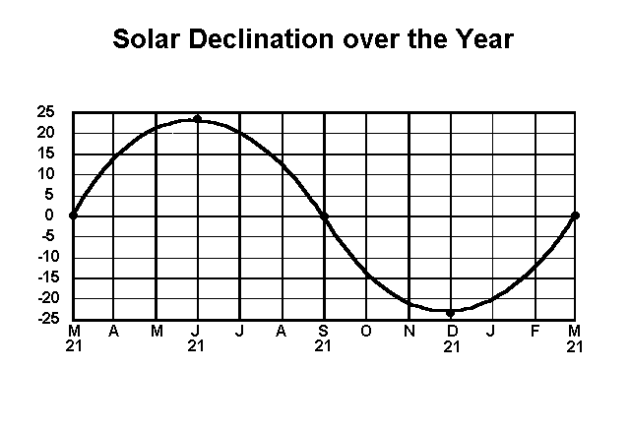

**Date Name Latitude**

≈21 Mar Vernal Equinox 0

≈21 June Summer Solstice 23.5 N

≈21 Sept Autumnal Equinox 0

≈21 Dec Winter Solstice 23.5 S

The graph to the right can be used to tell the latitude at which the Sun is overhead at all other times of the year. This latitude is called the **declination**, ***D* = **. It is approximately equal to



**Example 7**: Calculate the Solar Declination on October 15. If every month has 30 days then Oct 15 is 114 days from June 21.



**Time of Sunset and Sunrise** The sun rises and sets when it is at the horizon. If we neglect its finite angular width, this means that sunset and sunrise occur when ***Z*** = 90° or when cos(***Z***) = 0. The time of sunset, ***H*** is then given **in Radians** by



**______________________________________________________________________________**

**Example 8**: Calculate the time of sunset and sunrise on October 15 at latitude 41ºN.



Since there are 2 radians per 24 hours and 60 minutes per hour, multiply by 12/ to get sunset time in hours after noon or sunrise time in hours before noon and then convert the fractional hour to minutes. This yields 1.42×12/ = 5.44 = 5:26 PM and sunrise = 6:34 AM, assuming the day is centered around noon, local time.

**Example 9**: Calculate the Solar Zenith Angle, distance to the Sun, and solar Irradiance at latitude  = 41ºN on October 15 at 3:00 PM. Then calculate total solar heating per square meter and average solar irradiance over 24 hours.



To find the average solar irradiance, divide by 86400 seconds. This yields 251 Wm-2. **Mean solar irradiance on Earth is exactly 1/4th of the Solar Constant or 342 Wm-2.**

EAS 345 Lab #4 Name_____________________________________________________

Last First

**HEAT AND HYDROLOGY: EVAPORATION AND SNOWMELT**

**On math problems, show all work.**

Problems

1. Calculate the depth of water, ***z*** that will evaporate in 8 hours if the average sunlight striking level ground is 1000 W m-2 and ⅓ of the sunlight is used to evaporate water.

*z* = _______ m

2. a. Calculate the total sunlight striking level ground on 23 November at latitude 41°N and at 41°S.

*Q*tot = _________ J m-2 *Q*tot = _________ J m-2

b: Assuming 25% of this heat is used to evaporate water, calculate the depth of water evaporated per day and per year at this rate.

d*z* = _________m day-1 d*z* = _________m day-1

d*z* = _________m yr-1 d*z* = _________m yr-1

3. Calculate the depth of snow melted if 1 cm of rain with T = 5°C falls on the snow. Assume that the snow is initially at 0°C and that ρsnow = 100 kg m-3.

d*z* = _________m

4. Calculate the rates of heat transport and evaporation from a lake with *C* = 1.9(10)-3 if *v* = 5 m s-1,

*T*0 = 280 K *RH*0 = 100%,

*T*2 = 270 K *RH*2 = 30%.

[d*Q*/d*t*]/*A* = _________ W m-2

d*z*/d*t* = _______ m s-1 d*z*/d*t* = _______ m yr-1

5. Recalculate the rates of heat transport and evaporation in Problem 4 if both temperatures are raised 10°C and all other conditions remain the same.

[d*Q*/d*t*]/*A* = _________ W m-2

d*z*/d*t* = _______ m s-1 d*z*/d*t* = _______ m yr-1

6. Calculate the rates of sensible heat transfer and condensation onto a snow surface if T2 = 5°C, RH2 = 100% and v = 5 m s-1. Then compute the depth of melted snow as a result of each of these processes if the snow has a density, ρsnow = 100 kg m-3 and if the process continues for 5 hours. Compare this to your answer in problem 3.

Sensible Heat Transfer Condensation

[d*Q*/d*t*]/*A* = _____ W m-2 [d*Q*/d*t*]/*A* = _____W m-2

d*z* = _______ m d*z* = _______ m

7. Calculate the net radiation from a snow surface at -10°C when RH = 50%. You will first have to calculate *e*.

[d*Q*/d*t*]/*A* = _____ W m-2

8. Calculate the net upward radiation from the ground in the Sahara desert if the temperature is 40°C and RH = 10%.

[d*Q*/d*t*]/*A* = _____ W m-2

9. Use the 4-panel graph to calculate daily potential evaporation, given that

*T* = 70ºF *T*d = 60ºF *I*avg = 300 W m-2 ≈ 600 cal cm-2 day-1 *v* = 5 m s-1 ≈ 10 mph

*PE* = _________ in day-1

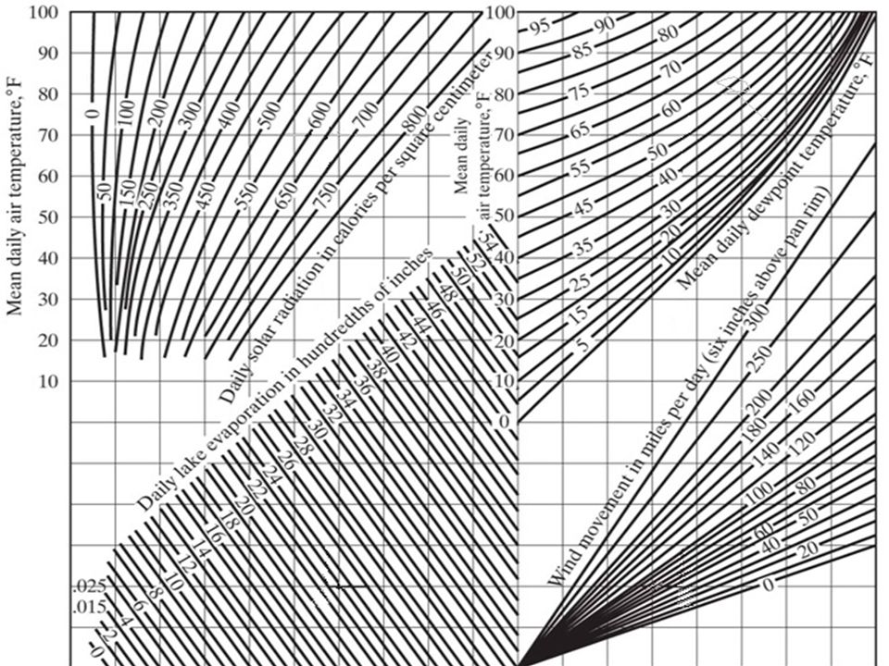



EAS 345 HYDROLOGY Lab #5 Name__________________________________

Last First

**INFILTRATION AND FINITE DIFFERENCE TECHNIQUES**

Introduction. Infiltration is the rate at which surface water percolates into the ground. It is often expressed as cm or inches per hour, but the SI amount is m s-1. (3.6 cm/hr = 10-5 m s-1.) The rate depends on a number of factors including soil type, soil moisture, vegetation, and temperature. Typically, the smaller the grains of soil, the more slowly water percolates into the ground. Also, the wetter the ground, the less room there is for water to infiltrate and consequently, the slower the rate.

Horton's Theory of Infiltration. Horton's theory is based on the fact that infiltration is faster in dry ground, so as rain continues and the ground becomes wetter, the infiltration rate decreases. The reason that infiltration is faster when the ground is dry is that there are more spaces for the water to fit so capillary forces that pull the water down into the ground are stronger.

**Horton's Equation** is the governing heuristic equation for infiltration,

 **(1)**

where,

*f* = infiltration rate

*f*0 = (initial) infiltration rate for dry ground

*f*c = (asymptotic) infiltration rate for saturated ground

*k* = infiltration constant

The infiltration equation is written with (*f* - *f*c) on the left hand side (rather than isolating *f*) because it is the excess infiltration rate above the value for saturated ground that diminishes exponentially with time.

Integrating Horton's equation over time gives the total depth of water that has infiltrated, *F*,

 **(2)**

**•Example 1**

Calculate the infiltration rate and the total depth of infiltrated water after 3 hours of hard rain.

Information:

*f*0 = 7.2 cm hr-1

*f*c = 0.2 cm hr-1

*k* = 0.75 hr-1

Solution:

Infiltration rate.



Total depth of infiltrated water.



**Limits to Horton's Theory**

Horton's equation and integral assume that the rainfall rate, *R* is greater than the infiltration rate throughout the rain. If at any time the rainfall rate is slower than the infiltration rate, the ground will lose some water to lower levels, and Horton's theory must be modified.

**Simple Model of Infiltrating Water**

Infiltration can be modeled by a layer of ground in which water enters through the top at a rate, *f* = *f*in and leaves through the bottom (into the water table) at a rate *f*out. As soon as any water is stored in the ground, storage *S* > 0 and,

 **(3)**

The depth of water stored in the layer, *S*, is equal to the total depth of infiltration, *F* minus the depth of water that has leaked out the bottom of the layer. Except in very permeable soil (such as sand or gravel, water leaks out the bottom so slowly, it is safe to assume that during any rainfall,

 **(4)**

The infiltration rate, *f*in is limited by the rainfall rate and by the total amount of stored water in the layer,

 (**5)**

R = Rainfall Rate and *S*max = maximum depth of water layer can store

Solving Horton's Equation yields the value for *S*max,

 **(6)**

The rate at which water is stored in the layer is equal to the infiltration rate minus the outflow rate through the bottom of the layer, or,

 **(7)**

The difficulty with this equation is that Eq. (5) for *f*in is complicated. If rainfall is ever less than the possible infiltration rate, then it is necessary to solve Eq. (7) numerically, using finite difference techniques.

Finite Difference Techniques. The secret of finite difference techniques is to replace derivatives by finite differences. This transforms a differential equation into an arithmetic equation that can be solved easily. Solving a differential equation using finite differences involves several steps.

1. Replace all derivatives with differences.

2. Solve the equation for the unknown (generally the future value).

2. Choose a value for the time step (*Δt*) or a distance interval.

3. Substitute current values to find the future value of the variable.

4. Iterate, or, update by repeating step 3 as much as needed.

The derivative is defined as,

 **(8)**

The finite difference technique assumes that the difference equals the derivative. Then we write the infiltration equation, Eq.(8) in finite difference form and rearrange to solve for ***S*(*t*+*Δt*)** because it is the only unknown.

**Finite Difference Infiltration Equation**

 **(9)**

Finally, overland flow occurs when the rainfall rate is greater than the infiltration rate. In that case,

 **(10)**

Now we are ready to solve a problem.

**•Example 2**

Use the finite difference technique to find the infiltration rate, the storage, and the overland flow assuming the same ground conditions as Example 1 and with rainfall rates of, rainfall rate is

(a) *R* = 4 cm/hr

(b) *R* = 8 cm/hr

First, solve for *S*max using Eq.(6). This yields,



Then in Column 4 below solve for fin using the bottom line of Eq (5). This tells the maximum possible infiltration rate. But the infiltration rate can never exceed the rainfall rate, R. Therefore, in Column 5 (fin) enter the smaller of the values in Column 3 and 4

|  |  |  |  |  |  |  |
| --- | --- | --- | --- | --- | --- | --- |
| *t* | *S(t)* | *R* | *f*c+(*f*0-*f*c)(*S*max-*S*)/*S*max | *f*in | *S*(*t*+*Δt*) | *R*xs |
| 0 | 0 | 4 | .2+7(9.33-0)/9.33=7.2 | 4 | 3.8 | 0 |
| 1 | 3.8 | 4 | .2+7(9.33-3.8)/9.33=4.3 | 4 | 7.6 | 0 |
| 2 | 7.6 | 4 | .2+7(9.33-7.6)/9.33=1.5 | 1.5 | 8.9 | 2.5 |
| 3 | 8.9 | 4 |  |  |  |  |

Note in the table above that *f*in is equal to the rainfall rate for the first two time steps. Only when the ground has filled sufficiently with water is the runoff given by the longer expression in Column 4.

Note also (see below) that when the rainfall rate is larger than the maximum possible infiltration rate, there is excess rain and overland flow.

|  |  |  |  |  |  |  |
| --- | --- | --- | --- | --- | --- | --- |
| *t* | *S(t)* | *R* | *f*c+(*f*0-*f*c)(*S*max-*S*)/*S*max | *f*in | *S*(*t*+*Δt*) | *R*xs |
| 0 | 0 | 8 | .2+7(9.33-0)/9.33=7.2 | 7.2 | 7.0 | 0.8 |
| 1 | 7.0 | 8 | .2+7(9.33-7)/9.33=1.9 | 1.9 | 8.7 | 6.1 |
| 2 | 8.7 | 8 | .2+7(9.33-8.7)/9.33=.67 | .67 | 9.17 | 7.33 |
| 3 | 9.17 | 8 |  |  |  |  |

EAS 345 HYDROLOGY Lab #5 Name__________________________________

Last First

**INFILTRATION AND FINITE DIFFERENCE TECHNIQUES**

**In Math Problems, show all work.**

1. A) Calculate all required quantities in the sheet for the Ring Infiltrometer Data.
2. Plot the data using Excel with f on the y axis (max value = 8 on graph) and time in min on the x axis
3. From the graph, estimate f0 = _______________ cm hr-1 and fc = ____________cm hr-1.
4. Use Horton's equation together with the values in the table and *f*o and *f*c to calculate *k*.

*k* = _______

2. Given initial and final infiltration rates

fo = 1.25 cm hr-1

fc = 0.05 cm hr-1

and the maximum storage.

Smax = _________cm

Calculate

|  |  |  |  |  |  |  |
| --- | --- | --- | --- | --- | --- | --- |
| t | S(t) | R | fc + (f0 - *f*c)(Smax-S)/Smax | fin | S(t+Δt) | Rxs |
| 0 | 0 | .5 |  |  |  |  |
| 1 |  | .3 |  |  |  |  |
| 2 |  | .2 |  |  |  |  |
| 3 |  | .7 |  |  |  |  |
| 4 |  | .9 |  |  |  |  |
| 5 |  | 1.1 |  |  |  |  |
| 6 |  | .6 |  |  |  |  |
| 7 |  | .3 |  |  |  |  |
| 8 |  | .5 |  |  |  |  |
| 9 |  | .4 |  |  |  |  |
| 10 |  | .4 |  |  |  |  |
| 11 |  | .6 |  |  |  |  |
| 12 |  | .5 |  |  |  |  |
| 13 |  | .4 |  |  |  |  |
| 14 |  | .4 |  |  |  |  |
| 15 |  | .2 |  |  |  |  |

Total Runoff or Rainfall Excess Σ*R*xs = ___________ cm

Total Infiltration *F* = ______________ cm

Total Rainfall *R*tot = ____________ cm

Ring Infiltrometer Data

These data were obtained in a concentric ring infiltrometer experiment on a rice paddy soil during the dry season in Thailand. Water was maintained at a depth of 1.5 cm inside both the inside ring and in the buffer ring. The inside ring had an internal diameter of 26 cm. The area of the experiment was 572 cm2.

The experimental data are given I the following table.

|  |  |  |  |  |  |
| --- | --- | --- | --- | --- | --- |
| time (min) | t (hr) | Vol H2O (cm3) | F (cm) | DF (cm) | f (cm/hr) |
| 0 | 0 | 0 | 0 | ----------------- |  |
| 1 | 0.0167 | 63 | 0.110 | 0.110 | 6.59 |
| 2 | 0.0167 | 120 |  |  |  |
| 5* | 0.0500 | 269 |  |  |  |
| 10 |  | 436 |  |  |  |
| 20 |  | 681 |  |  |  |
| 30 |  | 862 |  |  |  |
| 60 |  | 1153 |  |  |  |
| 90 |  | 1298 |  |  |  |
| 120 |  | 1440 |  |  |  |

* Air was observed bubbling out of the ground.

EAS 345 HYDROLOGY Lab 6 Name__________________________________

Last First

**GROUNDWATER**

**In Math Problems, show all work.**

Introduction. In many places, people obtain their water from the ground. The total ground water reservoir on Earth is some 8(10)6 km3, which far exceeds the capacity of all the world's rivers and lakes combined. This ground water is largely confined to the small spaces between grains of soil or in the small cracks in the rocks. Near the surface these spaces are only partly filled with water and partly filled with air. This zone is known as the vadose zone or the zone of aeration. Below a level known as the water table, all the pore spaces are filled with water.

Porosity is the percentage of the total rock volume that can be occupied by water. Thus if a column of rock 1 meter high has a porosity of *P*=.4 that means that if all the water were removed it would be a column .4 m high. Generally, the porosity of soils is about 20-40% and decreases with depth in the soil or earth!

A rock filled to its porosity is just like a soaked sponge. When the sponge is allowed to drip, it will not give up all its water. The percentage of water that can drip off by the action of gravity is known as the specific yield, *Sy*. Generally the specific yield of rock and soil is about 10-20%. When the soil or rock has dripped all it can the amount of water remaining is known as the field capacity. This water is held by capillary action, which increases as grain size decreases. At the field capacity plant roots can still extract some of the remaining water. Plants can extract ground water until it reaches a point known as the wilting point. For most soils except the finest clays, water volume percentage at the wilting point is somewhat less than 10%.

In a confined aquifer water cannot drip off so the available water is due to the compressibility of the rock and water layer, and is much less than the specific yield. The relevant quantity is then the Storativity, *S*, or the volume of water extracted from an aquifer per unit area and unit lowering of the head or the water table. *S* is typically 10-3 and 10-5 for a confined aquifer but equals specific yield, *S*y for an unconfined aquifer.

When water flows through the ground, the soil or rock is permeable. Most soils (except fine clays) and some rocks such as sandstone are permeable to some degree. Crystalline rocks such as granite are virtually impermeable unless riddled with joints and cracks. Permeable rocks are called aquifers while impermeable rocks are called aquitards.

Permeable soils and rocks have a high hydraulic conductivity, *K*. The hydraulic conductivity of different rocks and soils is highly variable. In general, the coarser the grains and the larger the cracks in the rocks the larger the value of *K*, which can range from 10-1 or higher in coarse gravel to less than 10-9 in fine clays and granite.

Many sedimentary rocks often are layered in such a manner that aquifers are confined between impermeable rock layers. Such layers are known as confined aquifers. Quite often it is necessary to drill a well through an impermeable layer to reach the aquifer. On occasion the pressure or head in the aquifer is so large that its water will rise and flow out on the surface once the impermeable layer has been penetrated. This is known as an artesian well.

The basic law of ground water flow is Darcy's equation,



1

where,

*q* is the discharge or flow rate

*A* is the cross sectional area

*K* is the hydraulic conductivity

*h* is the head or the height of the free water table.

Darcy's equation states that the rate of water flow is proportional to the slope of the water table, and water flows from points where the water table is higher to where it is lower. Water will generally flow downslope, but in cases where water is confined it may actually flow upwards.

The form of Darcy's equation is identical to the form of the classical heat conduction equation, and many of its solutions have been borrowed directly from solutions to heat conduction problems.

The flow per unit width in a confined aquifer of thickness, H is,



2

Because the product, *KH* appears so often, it is frequently combined into a single term, *T*≡*KH*, or *transmissibility*. (Spelling this word correctly gives an extra 20% on hydrology exams.) *T* is the volume discharge per unit width of aquifer when the slope of the head, ∂*h*/∂*x*=1.

The speed of the moving water in the ground for a given discharge varies inversely with the porosity. Since the volume of ground water d*V*w equals the volume of rock times the porosity, or, *P*d*V* we have after dividing by the time interval, dt,



3

Solving for the velocity, *v* yields,



4

When water is drawn from the ground it depresses the water table. The amount of water dVw that can be obtained is the volume of rock or soil, d*V* multiplied by the storativity, *S*. Once again, dividing by the time interval and noting that now d*V*=*A*based*h*, we get,



5

Because both *S*<1 and *P*<1, water moves faster through the ground and the water table changes somewhat faster than might be expected.

EAS 345 HYDROLOGY Lab 6 Name__________________________________

Last First

**GROUNDWATER**

**In Math Problems, show all work.**

1. Calculate the hydraulic conductivity, *K* for an unconfined aquifer with bottom at *h* = 0 where two piezometers 40 meters apart record heads (or water table heights), *h*1=50 m and *h*2 = 35 m. The discharge, *q*/L = 0.01 m3s-1/m is uniform and flows from *h*1 to *h*2.

*K* = _______

2. A confined aquifer 50 m thick with hydraulic conductivity, *K* = 10-3 and head with slope ∂*h*/∂*x* = 0.1 empties into a river 1 km long. Find the contribution of ground water flow into the river.

*q*Base = ________ m3 s-1

3. Find the total and available volume of water (to a well) in an aquifer 100 m thick with an area of 1 km2 if porosity, *P* = 0.4 and specific yield, *Sy* = 0.15.

*V*tot = _______ m3 *V*Avail = _______ m3

4. Calculate how long water in the aquifer of problem 3 would last if it is not replenished and if it is pumped at the rate, *q* = 0.01 m3 s-1

d*t* = __________ s

5. If 2 cm of rain falls but 0.8 cm runs off on the surface, calculate the rise of the water table if the specific yield, *Sy* = 0.2 and the soil was at field capacity.

*z* = ________ m

6. Find the rate of change of height of the water table, ∂*h*/∂*t*, in a rectangular area δx = 200 m long and δy = 100 m wide of an unconfined aquifer with bottom at *h* = 0 if the water table has a height *H* = 35 m on the left side and *H* = 20 m on the right and the slope of the water table ∂*h*/∂*x* = -.25 on the left and ∂*h*/∂*x* = -.10 on the right. Assume the porosity is *P* = 0.25, specific yield, *S*y = 0.15 and hydraulic conductivity, *K* = 10-4. To do this you must calculate the discharge at the left (inflow) and right (outflow) sides of the aquifer, take the difference to find the volume accumulation rate and divide by the surface area of the region.

∂*h*/∂*t* = ___________ m s-1

In this problem, the width, *y* of the region is irrelevant. Explain.

7. Find the speed of water moving through an aquifer with *K* = 10-5 and porosity, *P* = 0.4 if the slope of the water table, ∂*h*/∂*x* = 1.

*v* = _________ m s-1

8. Observations show that the total length of all tributaries is related to the watershed's area by,



6

where the length is in km and the area in km2. If the same unconfined aquifer as in Problem 7 empties into all the tributaries in an area, *A* = 100 km2, find the total length of the tributaries, and the total base flow that will result. Assume the aquifer is H = 35 m thick.

*L* = ______

*q*Base = ________ m3 s-1

EAS 345 HYDROLOGY Lab 7 Name__________________________________

Last First

**WELL FLOW AND GROUNDWATER**

**In Math Problems, show all work.**

Flow to wells is generally radial so that it is necessary to use cylindrical coordinates. I know that students generally hate cylindrical coordinates but what can I do? The flow to wells would remain radial even if the well were square! In simple problems the flow is entirely radial so that we need only include the radial distance, *r*, which is measured outward from the center of the well.

The flow to the well is then given by,



1

where *h* is the height of the water table. The cross sectional area, *A* is the area of the side of cylindrical can with radius r and height *H*, or,



2

For a confined aquifer, *H* is generally constant, while for an unconfined aquifer, *H* is variable.

When water is pumped from wells, the water table is depressed or drawn down in the vicinity of the well. Ground water then flows down the gradient toward the well to replace the extracted water. When water is first pumped from a well the water table sinks at a substantial rate, but after a while if the water is pumped from the well at a steady rate the water table approaches a steady height.

**Steady State Flow to Wells** The steady state flow of water to a well is a simpler problem than the unsteady problem. Steady flow means that there is no local accumulation of water at any region in the ground. Thus the discharge, *q* does not change with radial distance from the well.

There are two basic solutions for steady flow to wells - one for confined aquifers and one for unconfined aquifers. The difference hinges on the fact that H is constant for the confined aquifer and varies for the unconfined aquifer.

For the confined aquifer constant *q* implies that the bracketed term is constant, or



3

This means that we can separate variables and take the integrals,



4

After integrating and solving for *q*c this becomes,



5

For the unconfined aquifer the constant term in the brackets for constant *q* has changed since now, *h*=*H* and *H* is a variable. Thus,



6

Once again we separate variables and take the integrals,



7

After integrating and solving for *q*u, this becomes,



8

**Unsteady Well Flow** Of course, most well flow is unsteady. This is particularly true when a well is first dug and tested to estimate its potential yield.

The governing equation for the flow of water from a confined aquifer is the classical heat diffusion equation in cylindrical coordinates,



9

**Drawdown, you Cowards** Note that we use a new variable, *Z*r in place of *h*. *Z*r is the lowering of the height of the water table or the *drawdown*.

If a volume of water, *V*, is drawn impulsively at time *t*=0 from the well then the solution to the diffusion equation is,



10

We can generalize this solution by replacing *V* with *qdt* and integrating from 0 to *t* to get the well solution first used by Theis in 1935,



11

In shorthand this is written,



12

where,



13

and where *W(u)* is the so-called *well function*,



14

A graphical technique for solving well problems proceeds as follows. First of all when test wells are dug, neither *T* nor *S* is known. In order to solve for the well's future behavior, it is first necessary then to determine *T* and *S*.

1. The well is pumped for a while and the drawdown, *Z*r is recorded at a second test well (or *piezometer*) located at point, *r*p.

2. Plot *y*=*Z*r vs *x*=*r*p2/*t* on log-log graph paper.

3. Overlay the plot on a piece of log-log graph paper which has *y*=*W(u)* and *x*=*u* until the two curves match exactly.

4. Pick any value of *u*, and then write the values of W(u) and the values of *Z*r and *r*p2/*t* at the same point.

5. With these values use the equation for *Z*r to solve first for T. Then, use the equation for *u* to solve for *S*. At this point the solution is complete and can be used to find *Z*r at any other values of *t* and *r*.

The math for the well function can be simplified for large enough *t*. The well function is represented by the infinite series,



15

For large enough *t*, *u*→0 and the well function reduces to,



16

This approximation works quite well for *u*<.01. In this case we can write,



17

**Superposition of Several Wells and the Method of Images** The well equation is linear. This means that if there are several wells the drawdown is simply the sum of the individual drawdowns of each well. Thus, if there are two wells and the first draws water at rate *q*1 and is a distance *r*1 while the second draws water at *q*2 at a distance *r*2 from a particular point, then the total drawdown is,



18

It is possible to use virtual wells to solve two more difficult situations. When a river is nearby, then the water table at the river is fixed at the river level (no matter how rapidly the well pumps water). This problem is solved by placing a virtual well an equal distance across the nearest bank which pumps water *into the ground* at the rate, *q*. Then the drawdown is given by,



19

where *r*w and *r*i are the distances from the observation point to the real well and the image well respectively.

Finally, when the aquifer is finite and is terminated by impermeable rocks, then the drawdown can be expressed by placing a virtual pumping well an equal distance the opposite side of the end of the aquifer. The drawdown at any point is then given by,



20

where *r*w and *r*i are the distances from the observation point to the real well and the image well respectively. The one difference between the case of the river and the case of the finite aquifer is that the drawdown is larger in the case of the finite aquifer, so that the individual drawdowns are added rather than subtracted.

EAS 345 HYDROLOGY Lab 7 Name__________________________________

Last First

**WELL FLOW AND GROUNDWATER**

**In Math Problems, show all work.**

1. Water is pumped from a well in an unconfined aquifer at a rate *q* = 0.01 m3 s-1. A piezometer (test well) 100 m away (*r* = 100) records a steady height, *H* = 60 m. Find *H* at the edge of the well (*r* = 0.5 m) if *K* = 10-5.

*H* = _______ m

2. Calculate *K* for a steady well with *q* = 0.02 m3 s-1 in an unconfined aquifer, given that

r1=50 m H1=50.0 m

r2=20 m H2=45.5 m

*K* = _________

3. Find the maximum sustainable pumping rate for a well of *r* = 0.5 m in an unconfined aquifer with *h* = 60 m at a distance, *r* = 100 m if *K* = 10-4.

*q*max = _________ m3 s-1

4. For a confined aquifer, find *K* for a well pumping water at a rate q=0.01 m3s-1 if, H = 35 and

r1=40 m h1=40 m

r2=20 m h2=15 m

K = _________

5. Calculate the drawdown, *Z*r for an unsteady well of radius *r* = 0.5 m in a confined aquifer with *q* = 0.001, *S* = 2(10)-4, *H* = 40, and *K* = 9(10)-5 that has been pumping for 10 hours.

*Z*r = _______ m

6. Use the method of images to recalculate the drawdown for the well in Problem 5 if

a: a river is located 50 m away from the well

*Z*r = _______ m

b: the aquifer ends a distance 50 m from the well.

*Z*r = _______ m

7. Given a well with *T* = 10-3, *q* = 0.002, *S* = 2(10)-4, calculate the drawdown at a piezometer 25 m from the well at the times listed below.

|  |  |  |  |
| --- | --- | --- | --- |
| t | u | W(u) | Zr |
| 1 min = |  |  |  |
| 5 min = |  |  |  |
| 30 min = |  |  |  |
| 2 hours = |  |  |  |
| 5 hours = |  |  |  |

8. Water is pumped from a well in a confined aquifer at a rate, *q* = 0.003 m3 s-1. The drawdown at a piezometer a distance *r* = 20 m away as a function of time is given in the table below. Complete the table and use the graphs of *u* vs *W*(*u*) to find the transmissivity, *T*, and the specific yield, *S*c.

|  |  |  |
| --- | --- | --- |
| *t* | *Z*r | *t* (days) |
| 1 min= | 0.737 |  |
| 5 min= | 2.16 |  |
| 30 min= | 4.04 |  |
| 1 h= | 4.78 |  |
| 2 h= | 5.53 |  |
| 5 h= | 6.52 |  |

Procedure:

a: Plot the results from the table on the graph of *t* vs *Z*r.

b: Mark a value of 1/*u* vs *W*(*u*) along the curve on the transparency and write it below.

*1/u* = ________ *W*(*u*)=________

c: Overlay the observed curve of *t* vs *Z*r on the curve of 1/*u* vs *W*(*u*) and note the values of *t* and *Z*r at the marked point

*t*=________ *Z*r=_________

d: Solve for *T* and *S* by substituting into the drawdown equation and the equation for *u*. This leads to

*T* = ___________

*S* = __________

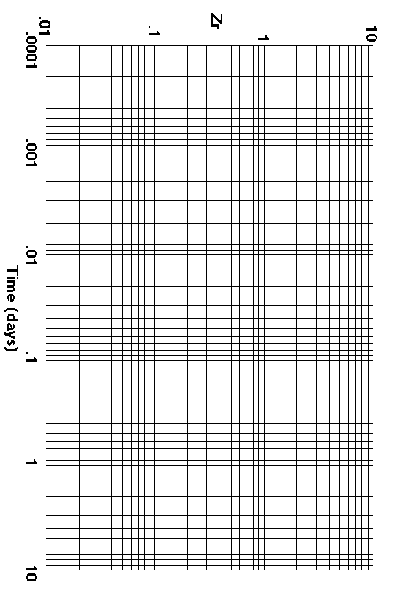

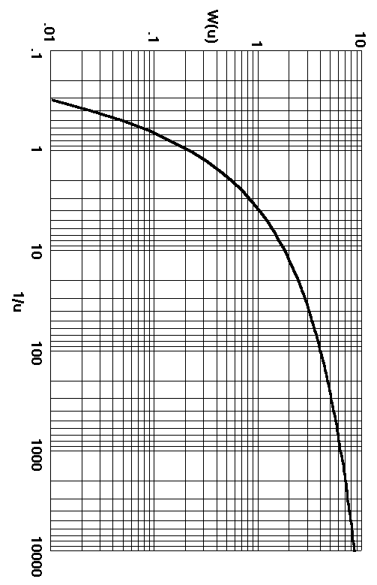

**EAS 345 HYDROLOGY Lab 8**

**STREAM DISCHARGE AND RATING CURVES**

**Introduction**

It is far easier to measure the stage (or water height) of a stream than its discharge. Discharge is measured by determining velocity profiles across the width and depth of the stream and adding the discharge from each segment. An example was given in Lab 1, where you also found

1. The wetted perimeter, *P*wet, or the length of the stream bed.

2. The cross section area, *A* of the stream.

3. The stream's hydraulic radius, *R* = *A*/*P*wet.

These quantities will be useful in Manning's Equation for Stream Flow (see next page),

The stream discharge is measured for a large range of different stages (this may take months to ensure a sufficient range of stages) so that in the future (provided the stream bed does not change) discharge is found by measuring the stage and using the rating curve.

The rating curve is a way to estimate the discharge from the stage and to forecast higher discharges on the basis of higher stages. Of course, the rating curve may not apply when extrapolated beyond the range of observations. Thus, discharges cannot be accurately assessed for some record floods.

Each point on a stream has its own equation to relate discharge to stage. This equation has the form,



1

where *q* is the discharge (m3 s-1), z is the stage. *K*, *b*, and *z*0 are constants that have to be determined. Thus, there are three unknowns.

In general the higher the stage the faster the flow and the greater the cross-sectional area of the stream. This implies that *b* > 1. The stream basically stops flowing when it gets so shallow that it is reduced to isolated pools of water. This occurs when the stage is *z*0.

**Technique for Determining the Rating Curve**

The rating curve is based on data that includes the discharge at a number of different stages. For example,

Stage z(m) Discharge q(m3 s-1)

.75 32.4

1.0 75.8

1.5 187.4

2.0 323.2

3.0 ______

First, find *z*0 by graphing *z* vs *q* and finding the value of *z* when *q = 0*.

This yields *z*0 ≈ 0.45

Then to find *K* and *b* it is best to take the natural log of the rating curve,

This can be expressed in the form, 

2

which is the equation of a straight line. The technique (from elementary algebra) is to find the slope (*b*) and intercept (log[*K*]) of this line by substituting two pairs of values of (*q*, *z*), or



3

Solving yields *K = 175* and *b = 1.4*. Thus the rating curve is,



4

This can now be used to compute the discharge when *z* = 3.0



5

**Manning Formula for Discharge**

One of the physically motivated formulas for stream discharge is the Manning Formula, because flow speed depends on slope and friction.



6

where

*n* = roughness coefficient

*A* = cross sectional area of stream

*P*wet = wetted perimeter (total length of stream bed from one bank to the opposite bank).

*R* = hydraulic radius = *A*/*P*wet

*S* = slope of river bed

**Bed Type n**

Paved .01

Average .04

Clogged >.1

The Manning formula makes physical sense because stream discharge is greater the smoother the bottom (*n* small), the steeper the slope (*S* large), the greater the cross sectional area (*A* large), and the deeper the river (*R* large).

Example: Calculate the discharge and average current velocity for a stream with slope S = .0001 and rectangular cross section that is 10 m wide and 3 m deep. Assume that the stream bed is very smooth so that n = .01.

Solution: First calculate the cross sectional area, the wetted perimeter, and the hydraulic radius.

*A* = 10(3) = 30 m2

*P*wet = 10 + 2(3) = 16

*R* = *A*/*P*wet = 30/16 = 1.875

Now use the Manning Formula to find discharge



7

The average current speed is equal to the discharge divided by the cross sectional area, or,



8

EAS 345 HYDROLOGY Lab 8 Name__________________________________

Last First

**STREAM DISCHARGE AND RATING CURVES**

**PROBLEMS**

**On Math Problems show all work.**

1. Find the rating curve for a stream with the following values of *q* and *z*,

Stage z(m) Discharge q(m3 s-1)

.5 7.9

1.0 36.2

1.5 71.6

2.0 111.7

3.5 ______

*z*0 = ________ (Plot this in EXCEL and extrapolate the curve to q = 0. After creating chart Click on Chart top menu bar, Add Trendline, Polynomial, Order 2, Options, Extend Line Backwards )

*K* = _______ *b* = _______

2. From the rating curve, find *q* when *z* = 3.5 m.

*z*(3.5) = _______m3 s-1

3. On a rainy day (24 hours) 10 cm of precipitation falls and all runs down the stream. If the basin area is, *A* = 109 m2

a. Calculate the mean runoff or discharge.

*q* = ___________m3 s-1

b. Will the stream flood? Flood stage is *z* = 3.5 m. Explain.

4. Use the Manning Formula to find the average current speed and discharge in a river with a rectangular bed that is 40 m wide, 4 m deep, has a slope, *s* = .002, and a very rough stream bed with *n* = .15.

*v* = ___________m s-1

*q* =_____________m3 s-1

5. Once every several years a natural stream or river overflows its banks. The water spreads out onto the floodplain. For the accompanying cross section of the Chemung River (a tributary of the Susquehanna River) at Elmira, NY, indicate the bounds of the floodplain on the contour map and on the cross section assuming that water level can rise 10 m above flood stage.

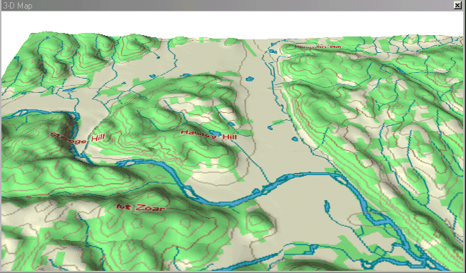

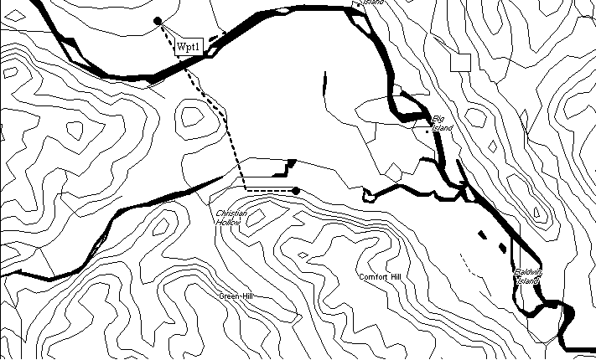

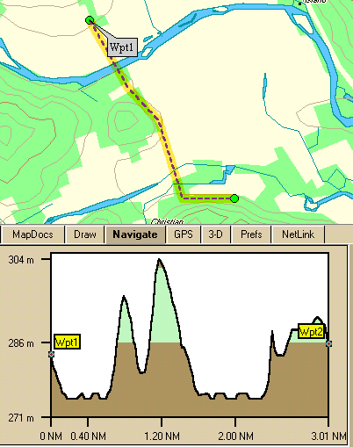

EAS 345 HYDROLOGY Labs 9 & 10 Name__________________________________

Last First

**HYDROGRAPHS**

**In Math Problems, show all work**.

Introduction. Hydrograph theory has been used with great success to forecast floods once the hydrologist knows the amount of rain and snow melt. Because every river has a well-defined, specific response to rain and overland flow due to melting snow, the hydrologist uses past hydrographs and rain events to determine the river's response to a simple rain event (such as a 1 cm rainfall in 1 hour). In most cases, the storm flow is proportional to the rainfall rate but the time lag between the rain and the peak flow depends only on the length of the river and does not vary with rainfall intensity. This means that rivers act largely in a linear manner. A basic tool of flood forecasting is to construct a unit hydrograph. The unit hydrograph is the discharge of a stream that results from a unit rainfall that occurs in a unit time. Each unit hydrograph includes both a peak discharge and a time lag between a unit rain event in a unit time and the peak discharge since it takes time for precipitation to run over the land to the rivers and then flow downstream. A basic property of the unit hydrograph is that if rain intensity doubles, so does peak discharge, but the time lag remains the same. Total discharges from complex rain events that vary in time and intensity are then calculated by adding unit hydrographs of each time unit of the total storm rain.

The Storm Hydrograph for a Complex Rain Event: To calculate the total discharge from complex rain events requires several simple steps:

1. Divide the rain event into time segments (e. g., 1 hour).

2. Multiply the rain of each segment by the unit hydrograph starting with the time the rain segment began.

3. Add the contributions of each segment at the appropriate time to the base flow for that time to get the total discharge.

Example: Consider the unit hydrograph

|  |  |  |  |
| --- | --- | --- | --- |
| time | 1 | 2 | 3 |
| Label | *U*1 | *U*2 | *U*3 |
| Value | 20 | 30 | 10 |

and the rain event,

|  |  |  |
| --- | --- | --- |
| time | 1 | 2 |
| Label | *R*1 | *R*2 |
| Value | 1.5 | .6 |

Assume the base flow remains constant at *q*b = 17.

At time *t* = 0, the rain has not yet begun so the total flow is simply the base flow,

*q*tot(0) = *q*b

At *t* = 1, the rain has begun and adds its first contribution, *U*1*R*1. Total flow is,

*q*tot(1) = *q*b + *U*1*R*1

At *t* = 2, both the second (*U*2) unit hydrograph for the first (*R*1) rain and the first (*U*1) unit hydrograph for the second (*R*2) contribute. The total flow becomes

*q*tot(1) = *q*b + *U*2*R*1 + *U*1*R*2

Completing the table yields

|  |  |  |  |  |  |  |
| --- | --- | --- | --- | --- | --- | --- |
| *t* | *q*b | *U*i*R*1 | Value | *U*1*R*2 | Value | *q*tot |
| 0 | 17 | - | - | - | - | 17 |
| 1 | 17 | *U*1*R*1 | 30 | - | - | 47 |
| 2 | 17 | *U*2*R*1 | 45 | *U*1*R*2 | 12 | 74 |
| 3 | 17 | *U*3*R*1 | 15 | *U*2*R*2 | 18 | 50 |
| 4 | 17 | - | - | *U*3*R*2 | 6 | 23 |
| 5 | 17 | - | - | - | - | 17 |

**End of storm flow**. The stream returns to normal 2 hours after the last hour of rain ends because the unit hydrograph for this stream lasts 3 hours.

River with Several Tributaries The same approach is used to calculate the total storm discharge for a river that has several tributaries. The hydrograph from each stream is added to get the total storm flow for the river

The S-Curve In the example above, the unit hydrograph indicates that the total volume of runoff from a unit rain event (e. g., 1 cm) is,

V = (*U*1 + *U*2 + *U*3)*d*t* = (20 + 30 + 10)(3600) = 216000 m3

If rain continued at the unit rate each hour forever, the stream would rise until the hourly discharge matched this value, or

*q*s = *U*1 + *U*2 + *U*3 = 60

Finding the Unit Hydrograph from a Complex Event Nature seldom provides simple rain events. If one is not available, the unit hydrograph can be calculated (and used for all future floods) by inverting the above approach. The technique is to proceed in order beginning with time, 0 when there is only base flow.

The base flow is then subtracted from all subsequent times to get the storm flow. At time *t* = 1, this yields

*q*tot(1) - *q*b(1) = *U*1*R*1

Solving for *U*1 yields,

*U*1 = [*q*tot - *q*b]/*R*1

At time *t* = 2

*q*tot(2) - *q*b(2) = *U*2*R*1 + *U*1*R*2

Solving for *U*2 yields

*U*2 = [*q*tot - *q*b - *U*1*R*2]/*R*1

This can be solved immediately since we already know *U*1.

Example:

|  |  |  |  |  |  |  |
| --- | --- | --- | --- | --- | --- | --- |
| *t* | 0 | 1 | 2 | 3 | 4 | 5 |
| *R* | - | .8 | .3 | - | - | - |
| *q*tot | 13 | 21 | 48 | 33 | 16 | 13 |

1. Because the stream returns to base flow 2 hours after the rain ends, we know that the unit hydrograph will have 3 terms. The base flow is constant at,

*q*b = 13

The first term of the unit hydrograph is,

*U*1 = [*q*tot - *q*b]/*R*1 = [21 - 13]/(0.8) = 10

The second term of the unit hydrograph is,

*U*2 = [*q*tot - *q*b - *U*1*R*2]/*R*1 = [48 - 13 - (10)(.3)]/(0.8) = 40

and so on.

Once the unit hydrograph has been found, it can be used to predict all future flood events at that point on the river.

EAS 345 HYDROLOGY Lab 9 Name__________________________________

Last First

**HYDROGRAPHS**

**In Math Problems, show all work**.

1. Go to the Internet at the web site (recall Lab 03)

<http://waterdata.usgs.gov>

and obtain daily discharge files for a river in the United States. For your river, find a series of several days that has a smooth, monotonic increase followed by a smooth, monotonic decrease

River and Station ________ Start Year, Month, and Date ______ _______ _______

Enter the data and plot it using EXCEL.

2. **PLOTTING A HYDROGRAPH** For the hydrograph data listed below, use EXCEL to plot the hydrograph of discharge vs time on the accompanying graph paper. Height is given in feet and Discharge is given in cubic feet per second.

This is taken from Example 12.16 (p. 433-434) in Elementary Hydrology by Singh.

**Time Gage Ht Discharge**

01:00 8.1 900

02:00 12.2 2205

03:00 15.6 3725

04:00 18.9 5280

05:00 26.2 6425

06:00 19.2 5425

07:00 16.0 3925

08:00 12.7 2445

09:00 9.7 1305

10:00 8.2 780

11:00 8.0 705

12:00 7.75 642

13:00 7.55 592

14:00 7.20 505

15:00 6.30 324

16:00 5.80 249

17:00 5.50 208

18:00 5.30 184

19:00 5.10 162

20:00 5.00 152

3. **CONSTRUCTING A UNIT HYDROGRAPH FROM A SIMPLE RAIN EVENT**

1. Plot *q* vs *t* on semilog graph paper to find the end of the hydrograph period.

2. Determine the base flow at beginning and end of period and then interpolate.

3. Subtract base flow each period to get storm discharge.

4. Divide by amount of precipitation to get unit hydrograph.

Rainfall, **R = .75 cm** occurred from t=0 to t=1

|  |  |  |  |  |
| --- | --- | --- | --- | --- |
| t | qtot | Base Flow | qstorm | Unit Hydrog |
| 0 | 37 |  |  |  |
| 1 | 42 |  |  |  |
| 2 | 132 |  |  |  |
| 3 | 275 |  |  |  |
| 4 | 435 |  |  |  |
| 5 | 445 |  |  |  |
| 6 | 316 |  |  |  |
| 7 | 209 |  |  |  |
| 8 | 145 |  |  |  |
| 9 | 111 |  |  |  |
| 10 | 90 |  |  |  |
| 11 | 79 |  |  |  |
| 12 | 71 |  |  |  |
| 13 | 64 |  |  |  |
| 14 | 58 |  |  |  |
| 15 | 54 |  |  |  |
| 16 | 51 |  |  |  |
| 17 | 50.5 |  |  |  |
| 18 | 50 |  |  |  |
| 19 | 49.5 |  |  |  |
| 20 | 49 |  |  |  |

4. **DETERMINE THE HYDROGRAPH FOR THE COMPLEX RAIN EVENT USING THE UNIT HYDROGRAPH**

Each rain value (RXS) is for the period ending at time t.

|  |  |  |  |  |  |  |  |  |
| --- | --- | --- | --- | --- | --- | --- | --- | --- |
| t | Unit | Base | RXS | R1U | R2U | R3U | R4U | qtot |
| 0 | -- | 29 |  |  |  |  |  |  |
| 1 | 20 | 30 | 0.50 |  |  |  |  |  |
| 2 | 80 | 31 | 0.75 |  |  |  |  |  |
| 3 | 280 | 32 | 1.25 |  |  |  |  |  |
| 4 | 450 | 33 | 0.25 |  |  |  |  |  |
| 5 | 500 | 34 |  |  |  |  |  |  |
| 6 | 400 | 35 |  |  |  |  |  |  |
| 7 | 200 | 36 |  |  |  |  |  |  |
| 8 | 100 | 37 |  |  |  |  |  |  |
| 9 | 50 | 38 |  |  |  |  |  |  |
| 10 | 25 | 39 |  |  |  |  |  |  |
| 11 | 12 | 40 |  |  |  |  |  |  |
| 12 | 6 | 41 |  |  |  |  |  |  |
| 13 | 2 | 42 |  |  |  |  |  |  |
| 14 |  | 43 |  |  |  |  |  |  |
| 15 |  | 44 |  |  |  |  |  |  |
| 16 |  | 45 |  |  |  |  |  |  |
| 17 |  | 46 |  |  |  |  |  |  |
| 18 |  | 47 |  |  |  |  |  |  |

EAS 345 HYDROLOGY Lab 10 Name__________________________________

Last First

**HYDROGRAPHS**

**In Math Problems, show all work**.

1. **DETERMINE THE HYDROGRAPH FOR A COMPLEX RAIN EVENT WITH TWO TRIBUTARIES USING UNIT HYDROGRAPHS FOR EACH**

Each rain value (RXS) is for the period ending at time t.

|  |  |  |  |  |  |  |  |  |  |  |  |
| --- | --- | --- | --- | --- | --- | --- | --- | --- | --- | --- | --- |
| t | qb1 | U1 | R1 |  |  | qb2 | U2 | R2 |  |  | qtot |
| 0 | 15 |  |  |  |  | 30 |  |  |  |  | qtot |
| 1 | 16 | 10 | 0 |  |  | 32 | 10 | 3 |  |  |  |
| 2 | 17 | 30 | 0 |  |  | 34 | 20 | 1 |  |  |  |
| 3 | 18 | 50 | 2 |  |  | 36 | 50 | 0 |  |  |  |
| 4 | 19 | 40 | 3 |  |  | 38 | 100 | 0 |  |  |  |
| 5 | 20 | 25 |  |  |  | 40 | 80 |  |  |  |  |
| 6 | 21 | 15 |  |  |  | 42 | 60 |  |  |  |  |
| 7 | 22 | 5 |  |  |  | 44 | 45 |  |  |  |  |
| 8 | 23 |  |  |  |  | 46 | 30 |  |  |  |  |
| 9 | 24 |  |  |  |  | 48 | 20 |  |  |  |  |
| 10 | 25 |  |  |  |  | 50 | 10 |  |  |  |  |
| 11 | 26 |  |  |  |  | 52 | 5 |  |  |  |  |
| 12 | 27 |  |  |  |  | 54 | 0 |  |  |  |  |
| 13 | 28 |  |  |  |  | 56 |  |  |  |  |  |
| 14 | 29 |  |  |  |  | 58 |  |  |  |  |  |
| 15 | 30 |  |  |  |  | 60 |  |  |  |  |  |

2. **CONSTRUCT THE S-CURVE USING THE UNIT HYDROGRAPH**

|  |  |  |  |  |  |  |  |  |  |  |
| --- | --- | --- | --- | --- | --- | --- | --- | --- | --- | --- |
| T | UNIT | Lag1 | Lag2 | lag3 | Lag4 | Lag5 | Lag6 | Lag7 | Lag8 | S |
| 0 | 0 |  |  |  |  |  |  |  |  |  |
| 1 | 75 |  |  |  |  |  |  |  |  |  |
| 2 | 250 |  |  |  |  |  |  |  |  |  |
| 3 | 300 |  |  |  |  |  |  |  |  |  |
| 4 | 275 |  |  |  |  |  |  |  |  |  |
| 5 | 200 |  |  |  |  |  |  |  |  |  |
| 6 | 80 |  |  |  |  |  |  |  |  |  |
| 7 | 30 |  |  |  |  |  |  |  |  |  |
| 8 | 15 |  |  |  |  |  |  |  |  |  |
| 9 | 0 |  |  |  |  |  |  |  |  |  |
| 10 |  |  |  |  |  |  |  |  |  |  |
| 11 |  |  |  |  |  |  |  |  |  |  |
| 12 |  |  |  |  |  |  |  |  |  |  |
| 13 |  |  |  |  |  |  |  |  |  |  |
| 14 |  |  |  |  |  |  |  |  |  |  |
| 15 |  |  |  |  |  |  |  |  |  |  |
| 16 |  |  |  |  |  |  |  |  |  |  |
| 17 |  |  |  |  |  |  |  |  |  |  |
| 18 |  |  |  |  |  |  |  |  |  |  |

Asymptotic Value of q = ____________ m3 s-1

4. **CALCULATING THE UNIT HYDROGRAPH FROM A COMPLEX RAIN EVENT**

|  |  |  |  |  |
| --- | --- | --- | --- | --- |
| t | qstorm | RXS | Equation and calculation | U |
| 0 | 0 |  |  |  |
| 1 | 10 | 1.0 |  |  |
| 2 | 120 | 2.0 |  |  |
| 3 | 400 | 0.0 |  |  |
| 4 | 560 | 1.0 |  |  |
| 5 | 500 |  |  |  |
| 6 | 450 |  |  |  |
| 7 | 250 |  |  |  |
| 8 | 100 |  |  |  |
| 9 | 50 |  |  |  |
| 10 |  |  |  |  |

3. **CALCULATING THE UNIT HYDROGRAPH FROM A COMPLEX RAIN EVENT**

|  |  |  |  |  |
| --- | --- | --- | --- | --- |
| t | qstorm | RXS | Equation and calculation | U |
| 0 | 0 |  |  |  |
| 1 | 20 | 2.0 |  |  |
| 2 | 130 | 3.0 |  |  |
| 3 | 330 |  |  |  |
| 4 | 410 |  |  |  |
| 5 | 310 |  |  |  |
| 6 | 210 |  |  |  |
| 7 | 120 |  |  |  |
| 8 | 45 |  |  |  |
| 9 | 0 |  |  |  |
| 10 |  |  |  |  |

How many terms does the unit hydrograph contain? ________

Explain your answer.

EAS 345 HYDROLOGY Lab 11 Name____________________________________

Last First

**HYDROLOGIC ROUTING**

**In Math Problems show all work.**

Introduction. Floods are controlled by building reservoirs because the water spreads out in the reservoir and does not rise as high downstream. In this lab exercise we calculate how the rise of the stream is reduced and the flood delayed by reservoirs or by the storage capacity of the stream bed itself.

Routing and Reservoir Storage: The procedure involves several steps:

1. Calculate upstream and downstream heights from the Manning equation for discharge.



1

where

*y*strm is stream width

*h* is stream depth

*s* is the slope of the stream bed

*n* is the Manning coefficient (usually *n* = .04)

In many reservoirs, water is allowed to flow either through orifices (pipes) or through weirs (channels cut in the top).

2. Use the equation for discharge of a weir or orifice to relate the discharge out of the reservoir to the height of the water. You should do this first to find the equilibrium level of the reservoir prior to the flood. You will also have to do this repeatedly to calculate the change of height of the water level.

Equation for discharge of circular orifice



2

where

*r* is the radius of the orifice

*h* is the height of the water surface

*h*o is the height of the orifice

Equation for discharge of rectangular weir



3

where

*y* is the width of the weir

*h* is the height of water over the weir

3. Solve the storage equation for height of the reservoir in finite steps.



4

where

*h*fut is the future height

*h*now is the present height

*A*Res is the area of the Reservoir

Δ*t* is the time step

*q*in is obtained from the Manning equation

*q*out is obtained from the weir or orifice equation

Warning: In all finite difference problems involvint time, if too large a time step, Δ*t*, is chosen then the model will give absurd numbers and may well crash. Smaller time steps mean that more calculations are needed, which doesn't bother the computer too much. When calculating by hand, it is best to choose the largest time step possible.

In the routing problem, the larger the area of the reservoir in relation to the maximum discharge, the larger the time step you can use.

Water Storage in Streams. As a flood wave moves downstream, the river acts like a narrow reservoir as it swells. As a result, the hydrograph has a lower peak but broadens in the downstream direction assuming no tributaries. The purpose of this exercise is to calculate downstream changes of the hydrograph.

The problem is solved by the program **STRMROUT**, but as usual, you must solve it by hand first.

In this problem the stream is given two segments only. Long rivers can be divided into many segments. A crucial point of the problem is that each segment depends on the water it gets from the segment upstream. Therefore at each time step the procedure is to solve for upstream segments first, and work your way mathematically downstream.

Warning: In large floods, the discharge in a river segment may also depend on the segment downstream if that becomes gorged and flow either backs up or slows down as a result. We will not consider that here.

EAS 345 HYDROLOGY Lab 11 Name____________________________________

Last First

**HYDROLOGIC ROUTING**

**In Math Problems show all work.**

1. Solve the routing problem for a reservoir capped by a weir, given that,

*A*Res = 5(10)6

*y*str = 50

*y*weir = 20

*s* = .002

Δ*t* = 3600

|  |  |  |  |  |  |  |
| --- | --- | --- | --- | --- | --- | --- |
| *t* | *q*in | *h*upstr | *h*Res | *q*out | Δ*h*Res | *h*dnstr |
| 0 | 30 |  |  |  |  |  |
| 1 | 40 |  |  |  |  |  |
| 2 | 150 |  |  |  |  |  |
| 3 | 430 |  |  |  |  |  |
| 4 | 590 |  |  |  |  |  |
| 5 | 530 |  |  |  |  |  |
| 6 | 480 |  |  |  |  |  |
| 7 | 280 |  |  |  |  |  |
| 8 | 130 |  |  |  |  |  |
| 9 | 80 |  |  |  |  |  |
| 10 | 30 |  |  |  |  |  |
| 11 | 30 |  |  |  |  |  |
| 12 | 30 |  |  |  |  |  |
| 13 | 30 |  |  |  |  |  |
| 14 | 30 |  |  |  |  |  |
| 15 | 30 |  |  |  |  |  |
| 16 | 30 |  |  |  |  |  |
| 17 | 30 |  |  |  |  |  |
| 18 | 30 |  |  |  |  |  |

2. Solve the routing problem for a stream consisting of two segments, given that *q*b is the base flow and *q*s is the discharge entering the first segment

*y* = 25 m Stream width

Δ*x* = 10 km length of stream segment

Δ*t* = 1000 s Time increment

*q* = 40*z*4/3 Rating curve for stream

Governing Equation for Height Change of a Stream Segment



5

|  |  |  |  |  |  |  |  |  |  |
| --- | --- | --- | --- | --- | --- | --- | --- | --- | --- |
| *t* | *q*b | *q*s | *q*tot | *z*1 | *q*1 | *Δz*1 | *z*1 | *q*2 | *Δz*2 |
| 0 | 10 | 0 |  |  |  |  |  |  |  |
| 1 | 10 | 20 |  |  |  |  |  |  |  |
| 2 | 10 | 50 |  |  |  |  |  |  |  |
| 3 | 10 | 90 |  |  |  |  |  |  |  |
| 4 | 10 | 70 |  |  |  |  |  |  |  |
| 5 | 10 | 50 |  |  |  |  |  |  |  |
| 6 | 10 | 30 |  |  |  |  |  |  |  |
| 7 | 10 | 20 |  |  |  |  |  |  |  |
| 8 | 10 | 10 |  |  |  |  |  |  |  |
| 9 | 10 | 0 |  |  |  |  |  |  |  |
| 10 | 10 |  |  |  |  |  |  |  |  |
| 11 | 10 |  |  |  |  |  |  |  |  |
| 12 | 10 |  |  |  |  |  |  |  |  |
| 13 | 10 |  |  |  |  |  |  |  |  |
| 14 | 10 |  |  |  |  |  |  |  |  |
| 15 | 10 |  |  |  |  |  |  |  |  |
| 16 | 10 |  |  |  |  |  |  |  |  |
| 17 | 10 |  |  |  |  |  |  |  |  |
| 18 | 10 |  |  |  |  |  |  |  |  |
| 19 | 10 |  |  |  |  |  |  |  |  |
| 20 | 10 |  |  |  |  |  |  |  |  |

EAS 345 HYDROLOGY LAB 12 Name__________________________________

Last First

A NUMERICAL APPROACH TO HDROGRAPHS

**In math problems, show all work**.

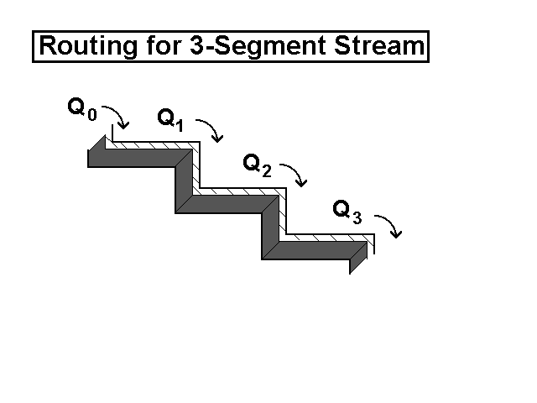

1

How does the unit hydrograph get its classical shape? We can show how by solving a stream routing problem much like the hydrologic routing problem. To calculate how a flood moves downstream to produce a hydrograph, the river is subdivided into distinct segments of length, Δ*x*. In each segment, overland flow *q*ov from a rainstorm reaches the river and adds to the stream flow. Water also flows into each segment from the segment upstream at a rate, *q*i-1, while water flows out of the segment at the downstream side at a rate, *q*i. The stage in any segment will change when there total inflow of water to the segment is not equal to the total outflow.

The equation for change of the *i*th stage, Δ*h*i based on mass conservation is,



1

where

Δ*t* is the time step

Δ*y* is the width of the stream

*q*i-1 is the incoming flow from the segment upstream

*q*i is the outgoing flow from the *i*th segment.

In this simple model, the downstream segments have no influence on the segments upstream. In reality, when the river rises downstream it can cause the stream to "back up".

The relation between stage and discharge may be given by

1. A rating equation,

2. The Manning Equation,

3. The equation for weir flow.

Steps:

1. At the first time step calculate the stage from the known discharge using a rating equation. (For simplicity, the discharge and stage are assumed equal in all segments. This is the base flow.)

2. At each subsequent time step use the equation for Δh to find the new stage. Then

3. Use the stream flow equation to find the new discharge. This must be done for the upstream segment first since changes of flow occur upstream first and influence the downstream segments.

4. Using the updated values of discharge, repeat steps 2 and 3 for the next time step and so on.

**Exercise #1**: No Overland Flow

Consider the simpler case with no overland flow. The stream is Δ*y* = 25 m wide. Each segment is Δ*x* = 20 km long, and has the same rating curve as for weir flow.



2

The problem is to calculate the discharge, *q*, for each segment and for each time until the flow peaks at the third segment. Every segment begins with the same flow and the same stage. To find the initial stage, solve the weir flow equation for *h*,



3

Assuming that the flow just begins to increase *t* = 1000, the river has not yet had any time to rise. Thus both *h* and *q* remain the same in all segments. This is why the first two lines have been completed in the table below.

t (s) q0 h1 q1 h2 q2 h3 q3

0 20 .27 20 .27 20 .27 20

1000 150 .27 20 .27 20 .27 20

2000 350

After *t* = 1000, *h*1 begins to increase since *q*0 > *q*1. The equation for the increase in stage of any segment, Δ*h*i, is given by



4

For the first segment this becomes,



5

Thus, at *t* = 2000, *h*1 = *h*1 + Δ*h*1 = 0.27+ 0.26 = 0.53 and *q*1 is given by



6

t (s) q0 h1 q1 h2 q2 h3 q3

2000 350 .53 56 .27 20 .27 20

3000 500

Note that the stream has not yet changed in segments 2 and 3. But after *t* = 2000 *h*2 begins to increase since *q*1 > *q*2. Segment 3 will not begin to rise until after t = 3000.

**Problem 1** Complete Table I below, explaining the downstream change in timing and quantity of discharge.

**Exercise #2**: Overland Flow

The only change is to add the effect of overland flow, which must be specified for each time and segment.

Table of Overland Flow

t (s) q0 qov1 qov2 qov3

0 20 0 0 0

1000 150 50 50 50

2000 350 50 50 50

3000 500 50 50 50

4000 450 50 50 50

5000 350 0 0 0

As before, nothing changes until after *t* = 1000. In this case, all segments that receive overland flow will begin to rise after *t* = 1000.

The change of height for the first segment is given by,



7

This leads to a height *h*1 = .63 at *t* = 2000 and a discharge,



8

The change of height for the second (and third segment) is given by,



9

This leads to a height *h*1 = .37 at *t* = 2000 and a discharge,



10

Thus,

t (s) q0 h1 q1 h2 q2 h3 q3

0 20 .27 20 .27 20 .27 20

1000 150 .27 20 .27 20 .27 20

2000 350 .63 72 .37 32 .37 32

**Problem 2** Complete Table II. Note the downstream changes in timing and magnitude of the discharge and comment on any differences that may be caused by including the overland flow. Given a long enough river (with more segments) and a long enough rainstorm, downstream flow will increase. But that will take more calculations and is a job for the computer.

EAS 345 HYDROLOGY LAB 12 Name_________________________________

Last First

A NUMERICAL APPROACH TO HDROGRAPHS

**In math problems, show all work**.

**Exercise 1** : No Overland Flow

Governing Equations:

Δ*h*i = ________________________ *q*i = ________________________

**Table I**

|  |  |  |  |  |  |  |  |
| --- | --- | --- | --- | --- | --- | --- | --- |
| t (s) | q0 | h1 | q1 | h2 | q2 | h3 | q3 |
| 0 | 20 | .27 | 20 | .27 | 20 | .27 | 20 |
| 1000 | 150 | .27 | 20 | .27 | 20 | .27 |  |
| 2000 | 350 | .53 | 56 |  |  |  |  |
| 3000 | 500 |  |  |  |  |  |  |
| 4000 | 450 |  |  |  |  |  |  |
| 5000 | 350 |  |  |  |  |  |  |
| 6000 | 250 |  |  |  |  |  |  |
| 7000 | 180 |  |  |  |  |  |  |
| 8000 | 110 |  |  |  |  |  |  |
| 9000 | 60 |  |  |  |  |  |  |
| 10000 | 20 |  |  |  |  |  |  |

Graph *q*0, *q*1, *q*2, and *q*3 as a function of time, and in the space below, show calculations for *t* = 3000.

EAS 345 Lab 12 Name______________________________________________________

Last First

**Exercise 2** : Overland Flow Included

Governing Equations:

Δ*h*i = ________________________ *q*i = ________________________

**Table II**

|  |  |  |  |  |  |  |  |
| --- | --- | --- | --- | --- | --- | --- | --- |
| t (s) | q0 | h1 | q1 | h2 | q2 | h3 | q3 |
| 0 | 20 | .27 | 20 | .27 | 20 | .27 | 20 |
| 1000 | 150 | .27 | 20 | .27 | 20 | .27 | 20 |
| 2000 | 350 | .63 | 72 | .37 | 32 | .37 | 32 |
| 3000 | 500 |  |  |  |  |  |  |
| 4000 | 450 |  |  |  |  |  |  |
| 5000 | 350 |  |  |  |  |  |  |
| 6000 | 250 |  |  |  |  |  |  |
| 7000 | 180 |  |  |  |  |  |  |
| 8000 | 110 |  |  |  |  |  |  |
| 9000 | 60 |  |  |  |  |  |  |
| 10000 | 20 |  |  |  |  |  |  |

Graph *q*0, *q*1, *q*2, and *q*3 as a function of time, and in the space below, show calculations for t = 3000.

**EAS 345 HYDROLOGY LAB #13**

**STATISTICS OF EXTREME FLOODING EVENTS**

**In Math Problems, show all work**.

**Introduction**. Hydrologists must plan for extreme events. Dams must be built high enough to contain or limit extreme floods, while bridges must be built high enough to remain above high water mark. The problem is how to plan for extreme events considering that they are so rare that we do not have comprehensive data to tell the 500 year event.

**Return Period and Probability** If a flood of a particular size (or greater) occurs on average once every *T*r years, then *T*r is called the return period and the probability, *p*, of such an event in any year is,



1

Then, the probability that there will be no such flood in a particular year is (1 - *p*) and the probability that there will be no such flood over the next *n* years is,



2

Example 1: If a flood of 5 feet or greater occurs on average once every 10 years, what is the probability it will not occur for the next 8 years?

Solution: Since the return period *T*r = 10, *p* = 0.1. Then *P*8 is



3

Thus, there is a 43% chance that there will be no such flood and a 57% chance that there will be *at least* 1 such flood. (There may be more than 1 such flood.)

Example 2: You are going to build a bridge and want to be 95% sure that it will not be destroyed by a 1000-year flood. How many years should you expect to have at this level of certainty?

Solution: Solve Equation 2 for *n* using *p* = 0.001 and *P*n = 0.95



4

This means you have 51 years to get out of town.

Example 3: You want to be 99% sure that the bridge will not flood in the next 50 years. You must then prepare for a flood with a return period of ___?

Solution: Solve for *T*r = 1/*p*



5

Thus, to have a high degree of certainty over an extended time you must prepare for an extremely unusual event.

Our records of floods are too short to accurately include storms with return period of 4975 years. Thus we must develop statistics for unusual events based on limited samples taken over a century if we are lucky. To do this we assume that the frequency of large floods is governed by the Gumbel Type I Extreme probability distribution given by,



6

Gumbel's distribution is designed to use the existing data record to tell how large a flood with a return period of *T*r will be.

There are only three steps.

1. Use the data record to find the mean, , and standard deviation, σq of the maximum annual floods.



7

2. Select the return period, *T*r you wish, substitute the values for and σq, and then solve the Gumbel expression for *K*.



8

What this means is that an extreme flood with a return period of *T*r will be *K* standard deviations above the average maximum annual flood.

3. To find the discharge of the extreme flood, solve the equation,



9

Example 4: Find K for the 100 year event. (This means *T*r = 100).



10

Example 5: Find the discharge for the 100 year flood if the mean annual peak flood is = 5000 and the standard deviation is σq = 1000.

From Example 4 we already know that for the 100 year event, K = 3.14. Then



11

Example 6: You must build a levee to control the river flood plain against unusual floods. You want to be 99% sure that there will be no flood in the next 50 years that will surmount the levee. Using the data from Example 5, find the extreme flood's return period and discharge.

Solution: Example 3 gave the return period for this example, namely *T*r = 4975.5

Then solve for *K*



12

Then the maximum discharge is



13

EAS 345 HYDROLOGY LAB 13 Name__________________________________

Last First

**STATISTICS OF EXTREME FLOODING EVENTS**

**In Math Problems, show all work**.

1. You must build a levee to control the river flood plain against unusual floods. You want to be 99% sure that there will be no flood in the next 50 years that will surmount the levee. This defines the unusual flood for this problem. A ten year record of previous floods is given below. Use it and the Gumbel distribution to calculate

a. The return period for the unusual flood

b. The discharge of the unusual flood

c. The stage of the river for this flood.

For this use the Manning formula for stream flow



14

where *z* is the depth, *n* = .04 is the Manning constant and *s* = .0016 is the slope of the stream bed, and the river is *y* = 20 m wide with a simple, rectangular profile.

1. 912 6. 473

1. 436 7. 759
2. 512 8. 505
3. 645 9. 589

5. 617 10. 606

Perform all calculations manually. (You may check results against EXCEL)

*q*avg = ____________

σq2 = _________

*T*r =________

*q*max = _______

*z*max = _______

1. Get records of daily river discharge for your River (see Lab 03) on the Internet at either

<http://www.usgs.gov> Then go to Water Resources

<http://waterdata.usgs.gov>

<http://www.rivdis.sr.unh.edu/> For International Rivers

Save the file in text form

Open the file in EXCEL to get annual maximum daily *q* (*q*ann) for each year.

Create a file in EXCEL of *q*ann for the 30-year period. Column A = Year, B = *q*ann.

Using that file calculate the statistical quantities for the 30-year period,

avg = _____ σq = _____ *q*max(obs) = _____ *K* = _____ Tr = _____

and for the 1000-year period calculate *K*1000 = ____ *q*1000 = ______